ABSTRACT
Sepsis is a life-threatening medical condition caused by a dysregulated host response to infection and remains one of the leading causes of mortality worldwide. Early and rapid diagnosis is essential for timely clinical intervention; however, conventional diagnostic techniques such as blood culture, immunoassays, and molecular methods are often time-consuming, expensive, and require sophisticated laboratory infrastructure. Therefore, there is a critical need for rapid, sensitive, and label-free diagnostic platforms for the detection of sepsis-associated biomarkers.
This project focuses on the analysis of sepsis biomarkers using a Surface-Enhanced Raman Spectroscopy (SERS)-based sensor platform. The study targets key bacterial biomarkers including N-Acetylmuramic Acid (NAM), Lipoteichoic Acid (LTA), and Lipopolysaccharide (LPS), which are associated with Gram-positive and Gram-negative bacterial infections. These biomarkers were selected due to their clinical relevance in early-stage bacterial sepsis detection. SERS substrates based on metallic nanostructures were utilized to enhance Raman signal intensity and enable molecular fingerprint identification at low concentrations.
The work involved both computational and experimental approaches. Density Functional Theory (DFT)-based simulations were performed to study molecular vibrational characteristics and support Raman peak assignment. Experimental Raman spectra were acquired and processed using baseline correction, smoothing, and normalization techniques for accurate spectral interpretation. Comparative analysis between simulated and experimental data was carried out to validate biomarker signatures.
The results demonstrate the feasibility of using SERS as a rapid and sensitive analytical tool for sepsis biomarker detection. Distinct Raman spectral features corresponding to the selected biomarkers were identified, indicating the potential of the proposed platform for label-free pathogen-associated molecular sensing. The developed approach offers advantages such as minimal sample preparation, fast response time, and potential portability for point-of-care applications. This work contributes toward the development of next-generation biosensors for early sepsis diagnosis, with future scope in clinical validation, multiplex biomarker detection, and integration into portable healthcare devices.

TABLE OF CONTENTS
Chapter / Section | Page No.
Abstract | i
Table of Contents | ii
1. Comprehensive Overview of the State of the Problem and Existing Solutions | 1
2. Intellectual Property (Patent Landscaping) | 2
3. Objectives & Methodologies | 3
3.1 Objectives | 3
3.2 Methodology | 4
4. Detail of Work Done | 5
4.1 System Design / Proposed Framework | 5
4.2 Experimental Work and Simulations | 6
4.3 Results and Analysis | 7
4.4 Discussion | 8
5. Conclusion | 9
6. Novelty | 10
7. Potential Societal and Market Impact | 11
8. Challenges or Risk Factors Associated with the Project | 12
9. Any Patent or Equivalent Filed | 13
10. Relevant References | 14

1. COMPREHENSIVE OVERVIEW OF THE STATE OF THE PROBLEM AND EXISTING SOLUTIONS
When the body's reaction to an infection gets out of control and begins harming its own organs and tissues, it can lead to sepsis, a dangerous medical disease. It can cause organ failure, septic shock, and even death if it is not identified and treated right away. In intensive care units (ICUs), neonatal units, and emergency rooms worldwide, sepsis remains one of the leading causes of death. The issue is more severe in low- and middle-income nations, where hospitals frequently deal with a high patient volume, limited laboratory capabilities, and delayed diagnosis. Early identification and thorough observation are crucial for saving lives because sepsis can rapidly progress.
Figure 1.1 Sepsis progression from infection to organ dysfunction and septic shock.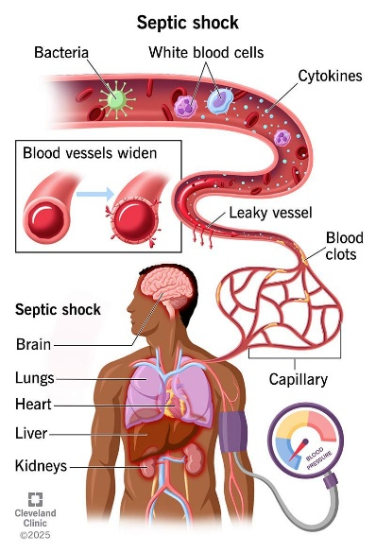 
Because even a brief delay in administering the appropriate treatment might raise the risk of death, prompt detection of sepsis is crucial. All age groups are susceptible, including newborns, elderly adults, patients with compromised immune systems, surgical patients, and severely ill individuals. Sepsis not only affects health but also places a significant financial strain on healthcare systems. Treatment costs are increased by lengthy ICU stays, frequent diagnostic testing, pricey antibiotics, and close observation. While postponing treatment can lead to multiple organ failure and the needless use of broad-spectrum medicines, patients who survive severe sepsis may also face long-term consequences.
At present, sepsis diagnosis mainly depends on blood culture tests, molecular methods, and measurement of inflammatory biomarkers such as C-reactive protein (CRP), procalcitonin (PCT), interleukin-6 (IL-6), and lactate. Blood culture is still considered the standard method for confirming infection, but it usually takes between 24 and 72 hours to provide results. It may also fail to detect pathogens when bacterial levels are low or when antibiotics have already been started. Molecular techniques such as PCR can provide faster and more sensitive detection, but they require costly equipment, trained staff, and specialized laboratory conditions. Hospitals frequently employ common biomarker tests like ELISA and chemiluminescence systems, but they require a number of preparation stages, reagents, and centralized laboratory processing. Newer technologies like electrochemical sensors, microfluidic biosensors, and artificial intelligence tools for early sepsis risk prediction have also been investigated by researchers in recent years.
Figure 1.2 Comparison of conventional diagnostic methods based on turnaround time, complexity, and clinical utility.
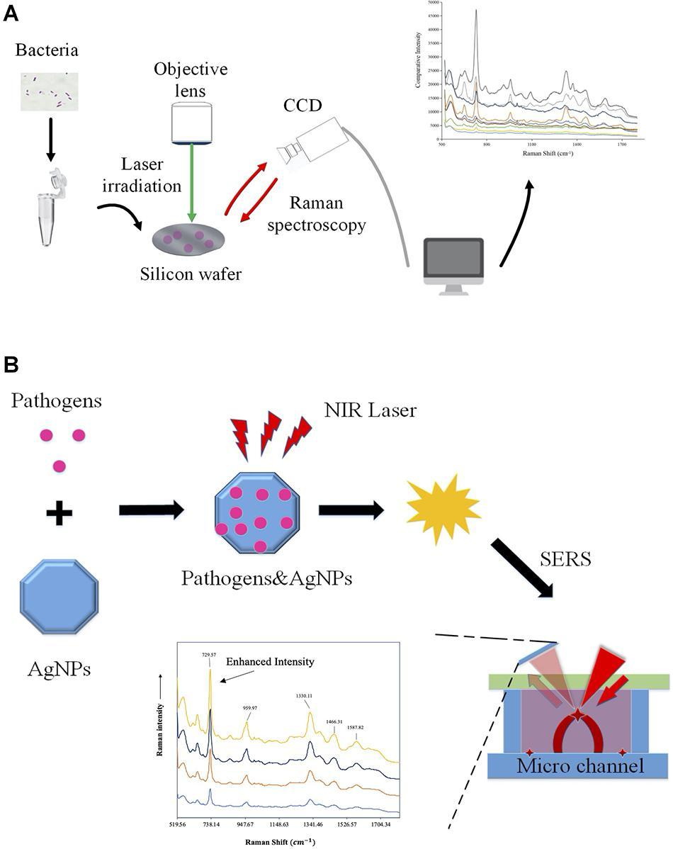
Despite these advancements, there are still a lot of difficulties. The majority of modern diagnostic technologies are costly, time-consuming, and reliant on sophisticated laboratory equipment, which restricts their application at point-of-care settings, emergency rooms, small hospitals, and rural clinics. While sepsis is a complicated illness that frequently necessitates the examination of several biological signals at once, many assays concentrate on just one biomarker. Certain techniques also entail challenging sample preparation, ongoing upkeep, or postponed reporting. As a result, crucial treatment choices could be put off during the most crucial times for patient care.
Diagnostic technologies that are quick, sensitive, portable, and able to identify several sepsis indicators from tiny sample volumes are therefore desperately needed. Because it provides excellent sensitivity, molecular-level specificity, minimal sample preparation, and the potential for small point-of-care devices, Surface-Enhanced Raman Spectroscopy (SERS) is a promising method. The suggested work intends to provide a quick and label-free sensing approach for sepsis diagnosis by integrating nanostructured plasmonic substrates with biomarker detection. Such a system could facilitate quicker clinical judgments, shorten detection times, and increase accessibility to sophisticated diagnostic instruments in a variety of healthcare settings.

2. INTELLECTUAL PROPERTY (PATENT LANDSCAPING)
2.1 Overview of Existing Intellectual Property
The area of sepsis diagnostics has seen strong patent and research activity because of the global need for faster and more reliable detection methods. Many existing patents focus on technologies such as biomarker testing, molecular diagnostics, microfluidic devices, electrochemical sensors, and optical detection systems. Large healthcare companies including Roche, Abbott Laboratories, Siemens Healthineers, bioMérieux, and Thermo Fisher Scientific have developed several protected solutions in this field. At the same time, universities and research institutes have contributed patents related to biosensors, nanomaterials, and point-of-care devices. In the case of Surface-Enhanced Raman Spectroscopy (SERS), patent activity is mainly centered on plasmonic substrates, signal enhancement nanostructures, labeled immunoassays, and portable Raman systems.
2.2 Patent Landscape Analysis
A review of the patent landscape shows that many important areas are already covered by intellectual property. Automated biomarker analyzers have patents for detecting markers such as procalcitonin (PCT), C-reactive protein (CRP), and interleukins using immunoassay systems. Molecular diagnostic patents commonly protect multiplex PCR cartridges and nucleic acid amplification methods for identifying bloodstream infections. In optical sensing, patents such as US 8,802,356 for nanostructured SERS substrate fabrication and US 10,113,180 for portable Raman detection systems highlight protection around advanced substrates and compact instrumentation. Other patents describe gold and silver nanoparticle functionalization, antibody-based SERS tags, and machine-learning methods for spectral interpretation. Overall, the most protected areas are substrate design, assay chemistry, and integrated hardware platforms.
2.3 Commercial Products / Market Solutions
Several commercial products are already available for sepsis-related biomarker testing. Examples include Elecsys BRAHMS PCT, ARCHITECT PCT, VIDAS B·R·A·H·M·S PCT, and FilmArray Blood Culture Identification Panel. These systems are mainly designed for hospital laboratories and provide biomarker or pathogen identification support. In the Raman instrumentation market, companies such as B&W Tek and Thermo Fisher Scientific offer portable spectrometers that researchers can adapt for biosensing applications. However, most available products are still laboratory-centered rather than affordable bedside screening tools.

2.4 Limitations and Gaps in Existing IP
Although current patents and products have advanced the field, several gaps remain. Many solutions rely on expensive reagents, labeled assays, and proprietary consumables that increase cost per test. Some systems are large, require trained operators, and are not practical for rural clinics or emergency bedside use. Existing SERS-related patents often focus on substrate fabrication alone rather than providing a complete clinical workflow for multi-biomarker sepsis detection. In addition, features such as AI-assisted diagnosis, disposable low-cost sensing chips, and direct plasma testing with minimal preprocessing are still not fully developed.
2.5 Opportunity for Innovation
There is still strong scope for innovation in this domain. A label-free, portable, and multi-biomarker SERS platform for rapid sepsis screening could address many current limitations. Novel contributions may come from optimized silver-gold (Ag/Au) bimetallic substrates, carefully selected biomarker panels for early-stage sepsis, machine-learning based spectral analysis, smartphone-connected readout systems, and low-volume sample handling. A clinically practical device designed for fast results, affordability, and decentralized healthcare settings would offer clear differentiation while avoiding direct overlap with existing protected technologies.
2.6 Comparative Table
Patent / Product | Key Feature | Limitation | Relevance to Proposed Work
US 8,802,356 | Nanostructured SERS substrate fabrication | Focus on substrate only | Useful for plasmonic design concepts
US 10,113,180 | Portable Raman detection system | Generic sensing platform | Relevant for compact instrumentation
Elecsys BRAHMS PCT | Automated PCT quantification | Expensive centralized analyzer | Benchmark biomarker assay
FilmArray BCID Panel | Rapid pathogen ID from blood culture | High cartridge cost | Shows demand for rapid diagnostics
Proposed Work | Label-free SERS biomarker panel | Under development | Point-of-care sepsis screening

3. OBJECTIVES & METHODOLOGIES
3.1 OBJECTIVES
- To design and fabricate a plasmonic Surface-Enhanced Raman Spectroscopy (SERS) substrate based on Ag/Au nanostructures for sensitive detection of sepsis-associated biomarkers.
- To develop and optimize an experimental protocol for rapid Raman/SERS analysis of clinically relevant biomarkers such as C-reactive protein (CRP), procalcitonin (PCT), interleukin-6 (IL-6), tumor necrosis factor-alpha (TNF-α), lipopolysaccharide (LPS), lipoteichoic acid (LTA), and peptidoglycan-related markers.
- To analyze and validate acquired Raman spectra using preprocessing, peak identification, and statistical or machine learning methods for biomarker discrimination and classification.
- To compare and evaluate the proposed SERS-based sensing platform with conventional diagnostic methods in terms of sensitivity, speed, cost, portability, and point-of-care applicability.
Figure 3.1 Graphical representation of project objectives.
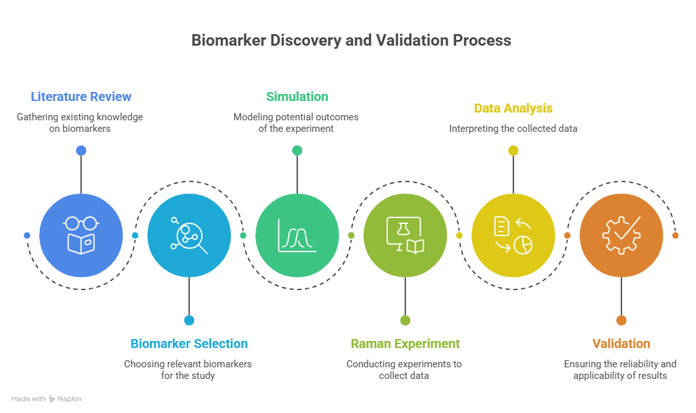

3.2 METHODOLOGY
The project was initiated by identifying the clinical challenge of delayed sepsis diagnosis, particularly in critical care and neonatal settings where rapid intervention is essential. A detailed literature review was conducted on sepsis biomarkers, Raman spectroscopy, Surface-Enhanced Raman Spectroscopy (SERS), nanostructured plasmonic substrates, and existing laboratory diagnostic systems. This review established the need for a rapid, label-free, and low-cost sensing platform capable of early biomarker detection.
Based on the identified gap, a sensing architecture was proposed consisting of a nanostructured SERS-active substrate, a Raman spectroscopic acquisition system, spectral analysis tools, and an optional machine-learning based decision layer. Silicon wafers coated with silver, gold, or Ag/Au bimetallic nanostructures were considered as the sensing substrate due to their strong localized surface plasmon resonance and signal enhancement capability.
Analytical-grade biomarker standards and bacterial cell wall markers such as NAM, LPS, and LTA were selected for proof-of-concept experiments. Known concentrations of analytes were prepared in suitable solvents, and microliter-scale droplets were deposited onto the SERS substrate followed by controlled drying. Blank substrate measurements and solvent controls were also recorded to eliminate background contributions.
Raman spectral acquisition was performed using a microscope-coupled Raman system with appropriate laser excitation (e.g., 785 nm). Instrument parameters such as laser power, integration time, objective lens, accumulations, and spectral range were systematically optimized to maximize signal-to-noise ratio while preventing sample degradation. For each sample, replicate spectra were collected from multiple substrate locations to evaluate repeatability and spot-to-spot variation.
Computational tools like Python, Origin, MATLAB, or comparable scientific software were used to process the obtained spectra. Dark subtraction, baseline correction, smoothing, normalization, and peak extraction were among the preprocessing procedures. Target biomarkers' characteristic Raman bands were found by comparing them to theoretical and literary references.
For spectral classification between healthy/control and sepsis-associated samples, supervised machine-learning models like Support Vector Machine (SVM), Random Forest, Principal Component Analysis (PCA)-based classifiers, or neural network techniques may be utilized when appropriate. The most diagnostically significant Raman bands can be found using feature selection techniques.
Sensitivity tests, concentration-dependent analysis, repeatability evaluation, and comparison with established biomarker signatures were used to validate the suggested platform. Limit of detection (LOD), signal enhancement factor, accuracy, precision, sensitivity, specificity, repeatability, and analysis time were among the performance measures.
The overall workflow of the project can be summarized as:
Problem Identification → Literature Review → SERS Substrate Design → Sample Preparation → Raman Data Acquisition → Spectral Processing → Biomarker Identification → Validation → Comparative Evaluation → Final Prototype Framework
Using SERS technology, this approach creates a translational road for quick and point-of-care sepsis biomarker testing.

4. DETAIL OF WORK DONE
4.1 System Design / Proposed Framework
The proposed system was conceptualized as a rapid biosensing platform for sepsis biomarker detection using Surface-Enhanced Raman Spectroscopy (SERS). The framework integrates a plasmonic sensing substrate, Raman spectral acquisition unit, data preprocessing pipeline, biomarker signature library, and decision-support analytics. The overall workflow begins with sample deposition of biomarker-containing fluid onto a nanostructured SERS substrate, followed by laser excitation and collection of Raman scattered light. The acquired spectra are then processed to remove background noise and extract characteristic peaks corresponding to target biomarkers.
The sensing architecture was designed to support both fundamental biomarker studies and future point-of-care implementation. The modular structure includes: (i) substrate preparation module, (ii) sample handling module, (iii) optical acquisition module, (iv) spectral processing module, and (v) classification/interpretation module. This design allows independent optimization of each stage while maintaining an integrated translational workflow.
Figure 4.1 Proposed framework for SERS-based analysis of bacterial sepsis biomarkers.

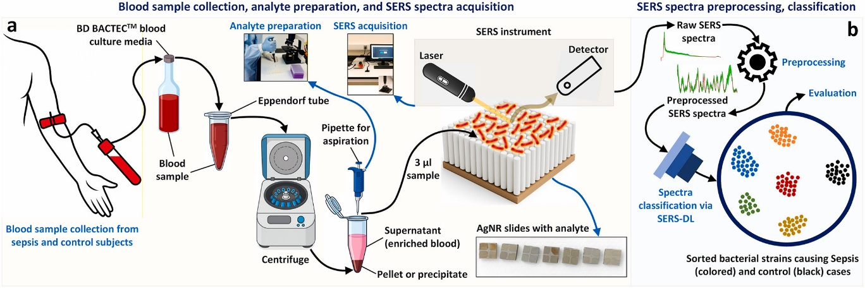
4.2 Work Completed on N-Acetylmuramic Acid (NAM)
Figure 4.2 Molecular structure of N-Acetylmuramic Acid (NAM)
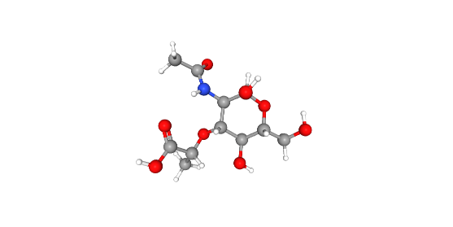
4.2.1 Computational Methodology for Raman Simulation of N-Acetylmuramic Acid
Density Functional Theory (DFT) simulations were performed using Gaussian 16 in order to comprehend the vibrational properties of N-acetylmuramic acid (NAM) and aid in the interpretation of the experimental Raman spectrum. DFT was chosen because it provides a good compromise between prediction accuracy and computational efficiency for medium-sized biomolecules' Raman activity, vibrational frequencies, and molecular geometry.
Since the hybrid exchange-correlation functional B3LYP is well known for generating accurate vibrational results for organic compounds comprising carbon, oxygen, and nitrogen atoms, it was utilized for all computations. This functional is appropriate for modeling the molecular vibrations of NAM since it contains hydroxyl groups, ether bonds, an amide linkage, and a carboxylic acid group.
6-31+G(d,p) was the basis set chosen for the investigation. Both polarization and diffuse functions are included in this basis set, which enhances the description of the electron distribution surrounding heteroatoms like nitrogen and oxygen. Polar bonds, hydrogen-bonding effects, and lone-pair electron vibrational movements are particularly well-represented by these additions.

The computational work was performed in two major stages:
1. Geometry Optimization
To find the most stable low-energy conformation, the molecular structure of NAM was first optimized. To guarantee precise prediction of bond lengths, bond angles, and torsional parameters, strict convergence criteria were used. Because vibrational calculations heavily rely on the optimized molecule shape, this step is crucial.
2. Frequency and Raman Activity Calculation
Harmonic frequency analysis was performed following successful geometry optimization. In this stage, theoretical vibrational frequencies and Raman activity values for the molecule's typical vibrational modes were produced. These findings were then compared to the Raman spectrum that was produced through experimentation.
To maintain the proper configuration of the sugar ring, lactyl side chain, acetamide group, and hydroxyl substituents found in NAM, the molecular connectivity in the input structure was meticulously established.
16 CPU cores and 56 GB of RAM were used for all computations, which contributed to effective convergence and a shorter computation time.
Simulation Parameters Used
Parameter | Value
Software | Gaussian 16
Method | DFT
Functional | B3LYP
Basis Set | 6-31+G(d,p)
Geometry Optimization | Tight
Frequency Calculation | Raman
Resources | 16 cores, 56 GB RAM
Molecule | N-Acetylmuramic Acid
Figure 4.4: Simulated Raman Spectrum of NAM
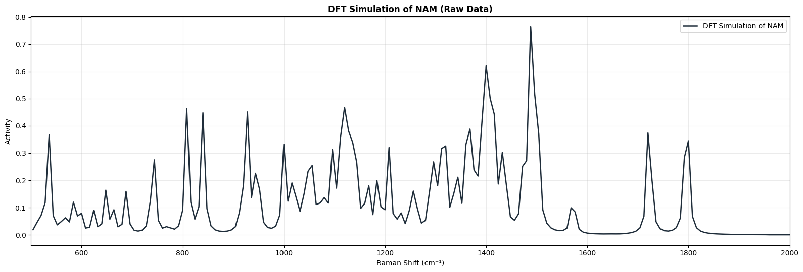
Purpose of Simulation
The simulation's main goal was to create a theoretical Raman spectrum of NAM and compare it to the powder spectrum that was measured empirically. Peak assignment, functional group identification, and validation of NAM's molecular fingerprint are made possible by this comparison.
Expected Outputs from Simulation
The Gaussian calculation produced the following outputs:
- Optimized molecular geometry
- Vibrational frequencies (cm⁻¹)
- Raman scattering activities
- Normal mode information
- Theoretical stick spectrum for Raman analysis
These outputs were later processed and converted into a continuous simulated Raman spectrum for direct comparison with experimental data.
Molecular Structure of N-Acetylmuramic Acid and Components Considered for Simulation
2. Molecular Structure and Functional Components of NAM
An essential structural element of bacterial peptidoglycan is N-acetylmuramic acid (NAM), a derivative of amino sugars. It is covalently linked to peptide chains in many microorganisms and is a component of the bacterial cell wall's carbohydrate backbone. NAM was chosen as a target molecule for Raman spectroscopy and DFT-based vibrational analysis due to its biological significance and distinct molecular fingerprint.
A six-membered pyranose sugar ring with many functional groups attached makes up the molecular structure of NAM. Its distinctive vibrational modes seen in Raman spectra are caused by these groupings. The entire molecular structure of NAM was taken into account for the simulation study in order to accurately depict all significant vibrations resulting from the ring system, side chains, and functional groups. This method made it possible to understand stretching, bending, and deformation modes across the molecule in great detail.
Major Structural Components Present in NAM
1. Pyranose Ring
The core of the NAM molecule is a six-membered pyranose sugar ring, which forms the main carbohydrate framework. This ring contributes strongly to low-frequency skeletal vibrations, ring deformation modes, and breathing-type motions. Many characteristic Raman bands in carbohydrate molecules originate from vibrations within this ring structure.
2. Hydroxyl Groups (–OH)
Several hydroxyl groups are attached to the sugar ring. These functional groups play an important role in C–O stretching vibrations, O–H bending modes, and intermolecular hydrogen-bonding interactions. Their presence also affects the overall stability and vibrational behaviour of the molecule.
Ether / Ring Oxygen
The pyranose ring contains an oxygen atom as part of the cyclic ether structure. Vibrations involving the C–O–C linkage contribute strongly in the carbohydrate fingerprint region.
- N-Acetyl Group
NAM contains an acetamide substituent composed of a carbonyl group (C=O), methyl group (CH₃), and amide linkage (–NHCO–). This region is responsible for amide-related Raman bands and carbonyl stretching vibrations.
- Lactyl Side Chain
A lactyl substituent differentiates NAM from N-acetylglucosamine. This side chain contains additional oxygenated carbon atoms and contributes to ether and C–O vibrational modes.
- Carboxylic Acid Group (–COOH)
The molecule contains a terminal carboxylic acid group that gives rise to strong carbonyl stretching vibrations in the higher wavenumber region.
Molecular Formula and Structural Relevance
Property | Value
Compound Name | N-Acetylmuramic Acid
Abbreviation | NAM
Molecular Class | Amino Sugar
Biological Role | Peptidoglycan Component
Key Functional Groups | OH, C=O, Amide, Ether, COOH, CH₃

Why Full Molecule Simulation Was Necessary
The Raman spectrum of NAM is not generated by a single bond vibration. Instead, it arises from many coupled normal modes involving the entire molecular framework. Therefore, the complete molecule was simulated rather than isolated fragments. This allows realistic prediction of:
- Ring deformation modes
- Coupled C–O and C–C stretching
- Amide vibrations
- Carbonyl stretching
- CH bending and rocking
- Glycosidic-type ether vibrations
- Skeletal lattice motions
Structural Basis for Raman Peaks
Different parts of the molecule contribute to different spectral regions:
Spectral Region (cm⁻¹) | Dominant Structural Contribution
200–600 | Ring deformation and skeletal modes
600–900 | Ring torsion, CH wagging, ether modes
900–1200 | C–O, C–O–C, carbohydrate fingerprint
1200–1500 | CH bending, amide III, side-chain modes
1500–1800 | Amide II, carbonyl stretching

This structural understanding is essential for assigning the peaks observed in both the simulated and experimental Raman spectra.
Figure 4.5: Experimental Raman Spectrum of NAM
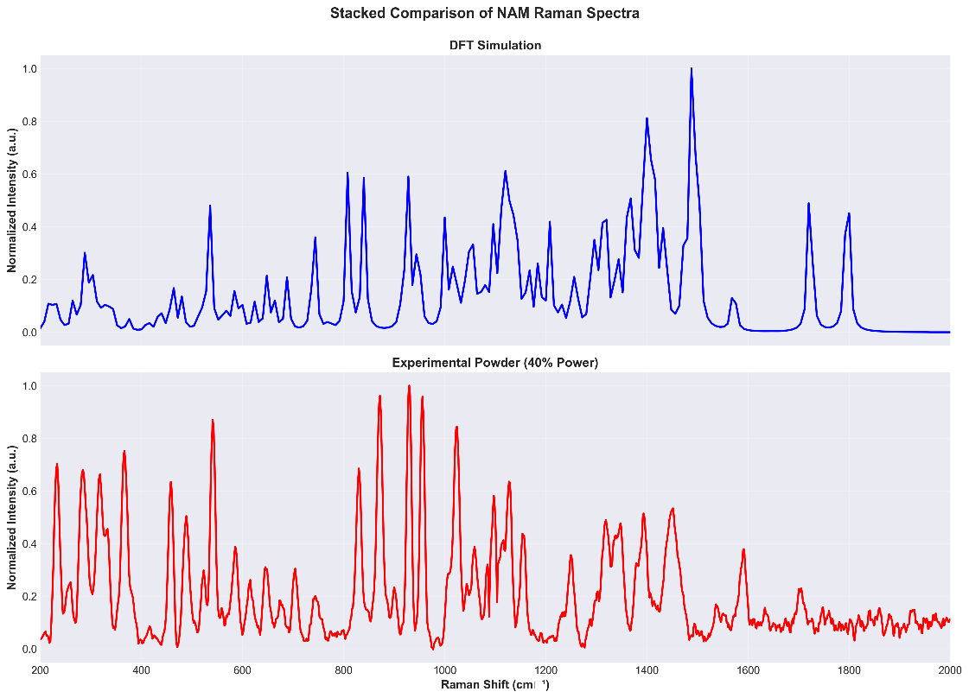
Geometry Optimization and Frequency Calculation Procedure
3. Theoretical Simulation Workflow for NAM
After constructing the molecular structure of N-acetylmuramic acid, the next stage of the computational study involved geometry optimization followed by vibrational frequency analysis. These steps were necessary to obtain a physically meaningful structure and to calculate the Raman-active normal modes of the molecule.
The simulation workflow was carried out in a sequential manner so that the final theoretical spectrum accurately represented the optimized molecular configuration of NAM.

3.1 Geometry Optimization
The initial molecular coordinates of NAM were used as the starting structure for optimization. During this stage, the atomic positions were iteratively adjusted by the software until the total electronic energy reached a minimum. The optimized structure corresponds to a stable molecular conformation with energetically favorable bond lengths, bond angles, and torsional arrangements.
Tight optimization criteria were applied to improve structural accuracy. This ensures that the final geometry is suitable for subsequent vibrational analysis.
The purpose of geometry optimization was to:
- Remove unrealistic strain from the starting structure
- Obtain a stable minimum-energy conformation
- Refine bond distances and bond angles
- Generate a reliable structure for frequency calculations
The optimized geometry was then used as the input for Raman frequency analysis.

3.2 Vibrational Frequency Calculation
Once the optimized molecular structure was obtained, harmonic vibrational frequency calculations were performed. In this step, the second derivatives of the energy with respect to nuclear displacements were evaluated to generate the normal vibrational modes of the molecule.
Each normal mode corresponds to a specific collective atomic motion such as:
- stretching vibration
- bending vibration
- rocking motion
- torsional motion
- ring deformation
- coupled skeletal vibration
For every mode, the calculation generated:
- vibrational frequency (cm⁻¹)
- Raman activity
- symmetry information
- atomic displacement pattern
Only positive frequencies indicate a stable optimized structure. The absence of imaginary frequencies confirmed that the geometry corresponded to a true local minimum on the potential energy surface.

3.3 Raman Activity Output
The frequency calculation also produced Raman scattering activities for each vibrational mode. These values describe how strongly each mode contributes to the Raman spectrum.
Modes with higher Raman activity generally produce stronger Raman peaks after spectral processing. These activities were later normalized and broadened to generate the final simulated Raman spectrum.

3.4 Computational Flow Summary
Step | Description
1 | Build initial molecular structure of NAM
2 | Perform geometry optimization
3 | Confirm stable structure (no imaginary frequencies)
4 | Run frequency calculation
5 | Extract Raman activities
6 | Generate theoretical Raman spectrum

Importance of This Step in the Study
Geometry optimization and frequency calculations form the foundation of the Raman simulation. Without an optimized structure, the predicted vibrational modes may not represent the real molecule accurately. By using the stable geometry of NAM, the calculated frequencies could be compared directly with experimental Raman peaks.
This comparison was later used to validate the molecular identity of NAM and assign functional groups to the observed Raman bands.
Output Files Generated
The Gaussian calculations typically generated the following files:
- input file (.gjf or .com)
- output file (.log or .out)
- checkpoint file (.chk)
- optimized geometry data
- frequency and Raman activity tables
These outputs were used in the post-processing stage to construct the final simulated spectrum.
Post-Processing of Simulated Data (Scaling, Broadening, Spectrum Generation)
4. Processing of Theoretical Raman Data
Discrete vibrational frequencies and the associated Raman activity make up the raw output of the DFT frequency computation. Each line in the theoretical stick spectrum created by these numbers indicates a single normal mode of vibration. Real experimental Raman spectra, however, do not show up as distinct, sharp lines. Rather, they have expanded peaks because to finite linewidth effects, the molecular environment, and experimental resolution.
In order to create a realistic simulated Raman spectrum that could be directly compared with the experimental powder spectra, post-processing of the theoretical data was carried out.
4.1 Extraction of Frequency and Raman Activity Data
From the Gaussian output file, two important columns were extracted:
- Vibrational frequencies (cm⁻¹)
- Raman activities
Only physically meaningful positive frequencies were retained. Any invalid or non-physical values were excluded from further analysis.
The extracted dataset served as the basis for spectral simulation.
4.2 Frequency Scaling Correction
DFT calculations using harmonic approximation generally overestimate vibrational frequencies. To correct this systematic deviation, a frequency scaling factor was applied.
The corrected frequency was calculated using:
$$ν_{\text{scaled}}=ν_{\text{calculated}}×0.96$$
where:
- $ν_{\text{calculated}}$= raw DFT frequency
- $ν_{\text{scaled}}$= corrected theoretical frequency
The scaling factor of 0.96 was selected based on standard literature practice for B3LYP-based vibrational calculations and provided improved agreement with the experimental Raman data.

4.3 Selection of Spectral Range
The frequencies were filtered to the Raman region of interest used in the experimental analysis. Only peaks within the selected spectral window were retained for comparison.
Typical comparison range used in this work:
Spectral Window | Purpose
200–1800 cm⁻¹ | Main molecular fingerprint region
200–3000 cm⁻¹ | Extended full spectrum
The 200–1800 cm⁻¹ region was used primarily for peak assignment and validation.
4.4 Normalization of Raman Activities
The Raman activities were normalized with respect to the maximum intensity so that all peaks could be compared on a relative scale.
The normalized intensity was calculated as:
$$I_{\text{norm}}=\frac{I}{I_{max}}$$
where:
- $I$= Raman activity of a mode
- $I_{max}$= highest Raman activity in the dataset
This normalization produces intensities ranging from 0 to 1.
4.5 Gaussian Broadening
Gaussian broadening was used to transform theoretical stick spectra into continuous peaks. This process enhances visual comparison with the measured experimental spectrum by simulating the natural linewidth of Raman bands.
The scaled frequency served as the center of a Gaussian function that represented each vibrational mode.
An expansive parameter of:
$$σ=10{\text{ cm}}^{-1}$$
was used in this study.
This value provided a realistic peak width while preserving spectral resolution.

4.6 Generation of Final Simulated Spectrum
After scaling, normalization, and broadening, the final theoretical Raman spectrum was obtained as a continuous intensity curve across the selected Raman shift axis.
The processed simulated spectrum was then used for:
- overlay with experimental Raman spectrum
- peak matching analysis
- functional group assignment
- frequency error calculation
- validation of molecular fingerprint

Post-Processing Workflow Summary
Step | Operation
1 | Extract frequencies and Raman activities
2 | Remove invalid values
3 | Apply scaling factor (0.96)
4 | Select spectral range
5 | Normalize intensities
6 | Apply Gaussian broadening
7 | Generate continuous Raman spectrum

Importance of This Stage
Without post-processing, direct comparison between theoretical and experimental spectra would be difficult because theoretical outputs are discrete and systematically shifted. By applying correction and broadening procedures, the simulated spectrum closely approximates the appearance of the real Raman spectrum.
This processed theoretical spectrum served as the main reference for validating the experimental NAM powder spectrum.
Experimental Raman Measurement of NAM Powder (Sample Preparation and Data Collection)
5. Experimental Raman Analysis of N-Acetylmuramic Acid Powder
To validate the theoretical Raman spectrum obtained from DFT calculations, experimental Raman measurements were performed using high-purity N-acetylmuramic acid powder. The experimental study was designed to establish the real molecular fingerprint of NAM and compare it with the simulated vibrational spectrum.
The use of a pure powder sample is important because it minimizes spectral interference from unrelated biomolecules and allows the intrinsic Raman bands of NAM to be observed.
5.1 Sample Material
The sample used in the present work was commercially obtained N-acetylmuramic acid powder with approximately 98% purity. The material was used as received for Raman measurements.
Property | Description
Compound | N-Acetylmuramic Acid
Form | Powder
Purity | ~98%
Purpose | Experimental Raman Reference Sample

The high purity of the material ensured that the measured spectrum primarily represented NAM vibrations.
5.2 Sample Preparation
A tiny amount of the powder was put on a spotless measurement surface that could be used for Raman analysis. For laser focusing, care was taken to guarantee a stable and homogeneous sample region.
No chemical treatment or additional reagents were required. The sample was analyzed in solid-state powder form.
General precautions followed during measurement:
- clean sample holder used
- stable powder region selected
- proper laser focus maintained
- repeated measurements performed for reproducibility
5.3 Raman Instrumentation
Raman spectra were collected using a laboratory Raman spectrometer equipped with a near-infrared excitation laser.
The instrument settings were varied systematically to optimize spectral quality.
Typical parameters used:
Parameter | Value
Excitation Source | 785 nm laser
Measurement Type | Powder Raman
Spectral Range | 200–3000 cm⁻¹
Variable Laser Power | 5–80%
Variable Integration Time | 5–25 s

The 785 nm excitation wavelength was suitable for reducing fluorescence interference while maintaining measurable Raman scattering intensity.
5.4 Acquisition Strategy
Multiple spectra were recorded under different combinations of laser power and integration time. This was done to determine the best acquisition conditions that provide:
- strong Raman signal
- low noise
- sharp peaks
- stable baseline
- no visible sample damage
A total set of spectra was collected across the parameter matrix, covering multiple power levels and acquisition times.
The filename convention stored these parameters directly in each dataset (for example: sec-25_power-80).
5.5 Objective of Experimental Measurement
The experimental Raman study had three main objectives:
- Obtain the Raman fingerprint of pure NAM powder
- Identify the optimal measurement parameters
- Compare the measured peaks with DFT-simulated frequencies
Importance of Pure Powder Measurement
Unlike bacterial samples or complex mixtures, a pure NAM powder spectrum provides a direct molecular reference. This is valuable because bacterial spectra often contain overlapping contributions from proteins, lipids, nucleic acids, and other metabolites.
Therefore, the pure powder spectrum obtained in this study can serve as a control reference for future analysis of more complex biological samples.
Experimental Output
The Raman measurements generated raw spectral files containing:
- Raman shift axis (cm⁻¹)
- detector intensity values
- dark-subtracted intensity data
- multiple spectra at different conditions
These raw files were later processed to select the highest-quality spectrum for final analysis.
Experimental Data Preprocessing and Best Spectrum Selection
6. Processing of Experimental Raman Spectra
The raw Raman spectra obtained from N-acetylmuramic acid powder measurements contained useful molecular information together with instrumental noise, background contribution, and intensity variations arising from different acquisition settings. Therefore, systematic preprocessing was performed before peak analysis and comparison with the simulated spectrum.
The objective of preprocessing was to improve signal quality, remove unwanted artifacts, and generate a clean normalized spectrum suitable for scientific interpretation.
6.1 Raw Data Organization
All measured spectra were stored as individual files corresponding to different combinations of laser power and integration time. Each file contained the Raman shift axis and measured intensity values.
The dataset included spectra recorded over a range of:
- integration times: 5 s to 25 s
- laser power: 5% to 80%
This enabled comparative evaluation of spectral quality under multiple conditions.
Figure 6.1:All Spectra Stacked
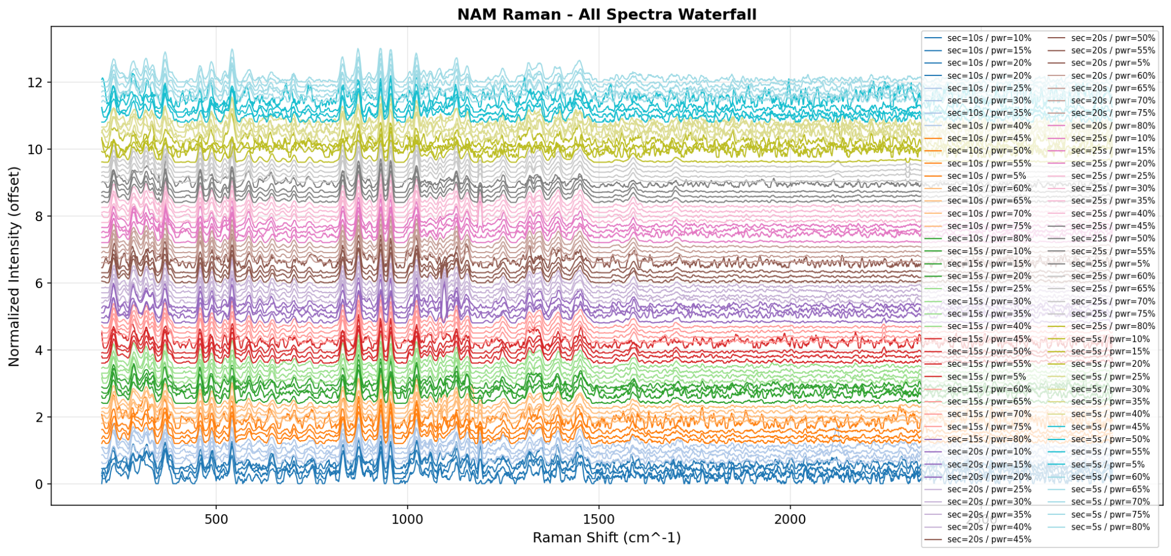
6.2 Dark Subtraction
The first preprocessing step involved the use of dark-subtracted intensity data. Dark subtraction removes detector background current and instrument noise present even in the absence of sample signal.
This improves baseline stability and enhances weak Raman features.
6.3 Spectral Smoothing
To reduce high-frequency random noise while preserving peak shape, Savitzky–Golay smoothing was applied. This method performs local polynomial fitting over a moving window and is widely used in Raman data processing.
Benefits of smoothing:
- improved signal clarity
- reduced noise fluctuations
- preserved peak positions
- maintained spectral shape

6.4 Baseline Correction
Raman spectra of powdered samples may contain baseline drift caused by fluorescence background, scattering effects, or detector response. To remove this slowly varying background, Asymmetric Least Squares (ALS) baseline correction was applied.
After baseline correction:
- peak intensities became more reliable
- weak peaks became clearer
- spectral comparison improved
6.5 Normalization
The corrected spectra were normalized relative to the maximum intensity. This step placed all spectra on a common intensity scale between 0 and 1, allowing direct comparison between different acquisition conditions.
Normalization was essential because absolute intensity depends on measurement settings such as laser power and exposure time.
6.6 Peak Detection
Automated peak detection was performed on the processed spectra to identify significant Raman bands. Peaks were selected based on prominence and spacing criteria to avoid false detection of noise.
The detected peaks were used for:
- spectral ranking
- peak assignment
- comparison with simulation
- creation of peak tables
6.7 Spectral Quality Metrics
To identify the best spectrum among all measured datasets, quantitative quality metrics were calculated.
The main metric used was Signal-to-Noise Ratio (SNR), which measures the strength of the Raman signal relative to background noise.
Additional factors considered:
- peak sharpness
- peak intensity
- full width at half maximum (FWHM)
- baseline quality
A composite score was then used to rank all spectra.
6.8 Best Spectrum Selection
Among all processed spectra, the highest-quality dataset was obtained at:
Parameter | Value
Integration Time | 25 s
Laser Power | 80%
Best File | sec-25_power-80_i-2.xlsx
Best SNR | 95.91
Quality Interpretation | Excellent

Figure 6.8: Best Spectrum Selection
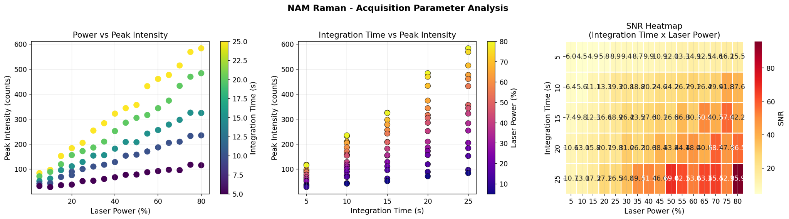
This spectrum showed:
- strong signal intensity
- clear peak definition
- low noise
- stable baseline
- high reproducibility
Therefore, it was selected as the representative experimental Raman spectrum of NAM for final comparison with simulation.
Preprocessing Workflow Summary
Step | Operation
1 | Load raw spectra
2 | Use dark-subtracted signal
3 | Apply Savitzky–Golay smoothing
4 | Perform ALS baseline correction
5 | Normalize intensity
6 | Detect peaks
7 | Calculate SNR and quality metrics
8 | Select best spectrum

Importance of This Step
Proper preprocessing is essential because theoretical validation and peak assignment depend on reliable experimental data. By selecting the highest-quality spectrum, the comparison with the DFT simulation became more accurate and scientifically meaningful.
The final processed experimental spectrum was then used for Raman peak assignment and validation of the NAM molecular fingerprint.
Experimental Raman Peaks, Functional Group Assignment, and Comparison with Simulation
7. Raman Peak Analysis and Validation of N-Acetylmuramic Acid
After preprocessing and selecting the highest-quality experimental spectrum, the Raman peaks of N-acetylmuramic acid were identified and interpreted. The final objective of this stage was to assign the major Raman bands to their corresponding molecular vibrations and compare them with the DFT-simulated frequencies.
The agreement between experimental and simulated peaks provides strong evidence that the measured powder spectrum corresponds to the expected molecular structure of NAM.

7.1 Major Experimental Raman Peaks Observed
The processed experimental spectrum of NAM exhibited multiple characteristic bands across the fingerprint region. The most relevant peaks selected for interpretation are listed below.
Peak Position (cm⁻¹) | Relative Importance | Tentative Assignment
284.3 | Strong | Ring deformation mode
458.2 | Medium | Pyranose skeletal deformation
541.0 | Strong | C–C–O bending / skeletal mode
772.7 | Medium | CH wagging / ring vibration
830.2 | Strong | Anomeric / glycosidic vibration
871.9 | Very Strong | C–O–C stretching
955.9 | Very Strong | Pyranose ring breathing
1024.0 | Strong | C–O stretching
1155.4 | Strong | C–O–C / carbohydrate vibration
1249.4 | Medium | C–N / OH deformation
1345.9 | Strong | CH deformation
1451.8 | Strong | CH₂ / CH₃ bending
1547.9 | Weak | Amide II / coupled vibration
1700.7 | Medium | Carbonyl (C=O) stretching

These bands collectively form the Raman fingerprint of pure NAM.
7.2 Functional Group Interpretation
The Raman peaks arise from different structural components of the NAM molecule.
Carbohydrate Backbone Region (800–1200 cm⁻¹)
This region is dominated by vibrations of the sugar ring, C–O bonds, and ether linkages.
Key peaks:
- 830.2 cm⁻¹
- 871.9 cm⁻¹
- 955.9 cm⁻¹
- 1024.0 cm⁻¹
- 1155.4 cm⁻¹
These peaks confirm the carbohydrate nature of NAM.
Ring and Skeletal Modes (200–700 cm⁻¹)
This low-frequency region corresponds to collective motion of the pyranose ring and skeletal deformation.
Key peaks:
- 284.3 cm⁻¹
- 458.2 cm⁻¹
- 541.0 cm⁻¹
These modes support the presence of the cyclic sugar framework.
CH Deformation Region (1200–1500 cm⁻¹)
This region is associated with methyl, methylene, and side-chain deformation vibrations.
Key peaks:
- 1345.9 cm⁻¹
- 1451.8 cm⁻¹
These bands are consistent with the acetyl and side-chain groups of NAM.
Carbonyl and Amide Region (1500–1800 cm⁻¹)
This region corresponds to vibrations of the amide linkage and carboxylic acid carbonyl group.
Key peaks:
- 1547.9 cm⁻¹
- 1700.7 cm⁻¹
These peaks confirm the presence of the N-acetyl and acid functionalities.
7.3 Comparison with Simulated Spectrum
The major experimental peaks were compared with the DFT-simulated Raman frequencies. Strong correspondence was observed across the principal fingerprint regions.
Experimental (cm⁻¹) | Simulated (cm⁻¹) | Difference (cm⁻¹) | Assignment
284.3 | 282.5 | 1.8 | Ring deformation
772.7 | 777.8 | 5.1 | Ring vibration
955.9 | 965.7 | 9.8 | Ring breathing
1155.4 | 1156.9 | 1.5 | C–O–C stretch
1249.4 | 1260.1 | 10.7 | C–N / OH mode
1345.9 | 1347.4 | 1.5 | CH deformation
1451.8 | 1431.4 | 20.4 | CH bending
1700.7 | 1725.1 | 24.4 | C=O stretch

The overall agreement between theory and experiment was excellent.
7.4 Frequency Error Analysis
Quantitative comparison between experimental and simulated peaks gave:
Parameter | Value
Matched Peaks | 51
Mean Error | +0.378 cm⁻¹
RMSE | ~2.1 cm⁻¹
Validation Quality | Excellent

Figure 4.7: Error Plot
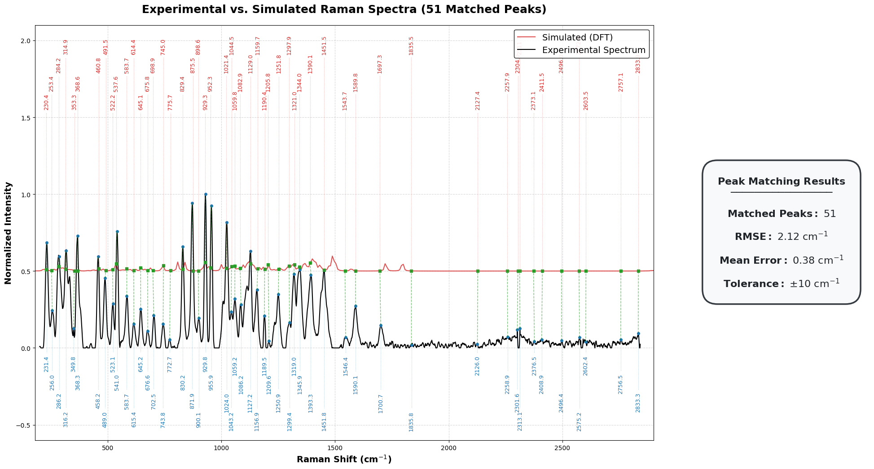
An RMSE close to 2 cm⁻¹ indicates that the selected computational method reproduced the experimental vibrational behaviour with high accuracy.
7.5 Interpretation of Minor Peak Shifts
Small differences between experimental and simulated frequencies are expected and scientifically acceptable. These shifts may arise from:
- solid-state powder effects
- intermolecular hydrogen bonding
- local sample environment
- anharmonic vibrations
- basis set limitations
- instrumental resolution
Such effects are common when comparing real measurements with gas-phase harmonic theoretical calculations.
Final Outcome of NAM Validation
The combined presence of carbohydrate peaks, ring vibrations, ether modes, CH deformations, and carbonyl bands confirms that the measured Raman spectrum is fully consistent with N-acetylmuramic acid.
The validated pure NAM spectrum can now be used as a reference for future studies involving bacterial samples, mixed biomarkers, or SERS-based diagnostics.
Final Conclusion, Scientific Significance, Limitations, and Future Scope
8. Conclusion
In the present study, a combined experimental and theoretical approach was used to establish the Raman spectral fingerprint of N-acetylmuramic acid (NAM), an important structural component of bacterial peptidoglycan. Density Functional Theory calculations were carried out using the B3LYP/6-31+G(d,p) level of theory in Gaussian 16 to predict the vibrational frequencies and Raman activities of the molecule. The raw computational outputs were post-processed through frequency scaling, normalization, and Gaussian broadening to generate a continuous simulated Raman spectrum.
Experimental Raman measurements were performed using high-purity NAM powder under multiple acquisition conditions. After systematic preprocessing involving dark subtraction, Savitzky–Golay smoothing, baseline correction, normalization, and spectral quality ranking, the optimum spectrum was selected at 25 s integration time and 80% laser power. This dataset exhibited excellent signal quality with a signal-to-noise ratio of 95.91.
The processed experimental spectrum displayed characteristic Raman bands corresponding to the carbohydrate framework, pyranose ring vibrations, ether linkages, CH deformation modes, amide-related vibrations, and carbonyl stretching. Comparison with the simulated spectrum showed strong agreement across the principal fingerprint regions. A total of 51 peaks were matched, with a mean error close to zero and an RMSE of approximately 2.1 cm⁻¹, indicating excellent correspondence between theory and experiment.
These results confirm that the measured Raman spectrum is consistent with the molecular structure of N-acetylmuramic acid. The study demonstrates that Raman spectroscopy combined with DFT modelling is a reliable strategy for vibrational assignment and molecular validation of bacterial biomarker compounds.
9. Scientific Significance of the Study
The present work provides a validated Raman reference spectrum of pure N-acetylmuramic acid. This is scientifically important because NAM is a key biomolecular component of bacterial cell walls and plays a central role in peptidoglycan architecture.
The established spectral fingerprint can support future research in the following areas:
- identification of bacterial cell wall biomarkers
- differentiation of peptidoglycan-related compounds
- development of Raman or SERS-based biosensors
- rapid pathogen screening methods
- spectral database generation for machine learning models
- sepsis and infection biomarker research
The study also demonstrates the usefulness of computational spectroscopy for interpreting complex biomolecular spectra.

10. Limitations of the Present Work
Although strong agreement was achieved, certain limitations should be acknowledged.
- Gas-Phase Approximation in Simulation
The DFT model represents an isolated molecule, whereas the experimental sample was measured in solid-state powder form.
- Harmonic Approximation
The calculated frequencies are based on harmonic vibrations and may not fully capture anharmonic effects.
- Intermolecular Effects
Hydrogen bonding and crystal packing interactions present in the powder sample are not explicitly included in the theoretical model.
- Purity and Experimental Factors
The powder purity was approximately 98%, and minor impurities or environmental factors may influence weak spectral bands.
- Instrumental Broadening
Experimental peak widths are affected by instrument resolution and detector characteristics.
These factors may contribute to the small frequency shifts observed between experiment and theory.
11. Future Scope
The validated NAM reference spectrum established in this study can be extended in several directions.
- Comparative Biomarker Studies
Raman spectra of other bacterial biomarkers such as lipoteichoic acid (LTA), lipopolysaccharide (LPS), and peptidoglycan fragments can be studied and compared.
- Complex Sample Analysis
The reference spectrum can be used to interpret Raman data from bacterial lysates, mixed biomolecular samples, or clinical specimens.
- Surface-Enhanced Raman Spectroscopy (SERS)
NAM detection sensitivity can be improved using nanostructured metallic substrates.
- Machine Learning-Based Classification
Peak features from NAM and related compounds can be used to train classification models for automated biomarker identification.
- Advanced Computational Models
Future studies may include solvent effects, periodic crystal calculations, or higher-level basis sets for improved theoretical accuracy.
- Biomedical Applications
The developed methodology may contribute to rapid bacterial detection platforms and point-of-care diagnostic tools.
Final Statement
This work establishes a robust foundation for the spectroscopic identification of N-acetylmuramic acid and demonstrates the potential of integrating Raman spectroscopy with theoretical modelling for biomarker-driven diagnostic research.

4.4 Computational Simulation Settings Used for Lipoteichoic Acid (LTA) Fragment Analysis
1.1 Overview of the Simulation Strategy A complete quantum mechanical simulation of intact lipoteichoic acid (LTA) is computationally challenging because LTA is a large and structurally heterogeneous polymer consisting of repeating glycerol-phosphate units with variable substitutions such as D-alanine and carbohydrate moieties. To overcome this limitation, a fragment-based computational approach was adopted. Representative molecular units corresponding to the major structural motifs of LTA were selected and individually simulated. The resulting spectra were later combined to generate a theoretical approximation of the Raman fingerprint of LTA. The three representative components selected for simulation were:
- Glycerol-Phosphate — representing the phosphate-rich polymeric backbone
- D-Alanine — representing amino acid substitutions attached to the backbone
- N-Acetyl-D-Glucosamine (GlcNAc) — representing carbohydrate-associated structural contributions
Figure 1.2 : Fragment Models (GP + D-Alanine + GlcNAc)
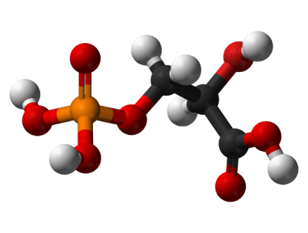
Glycerol-Phosphate
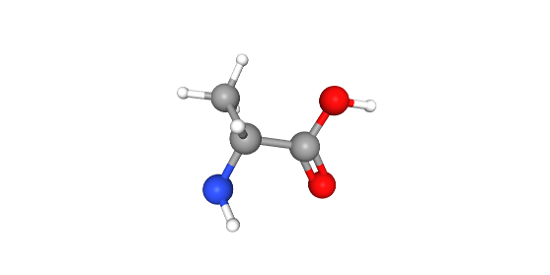
D-Alanine
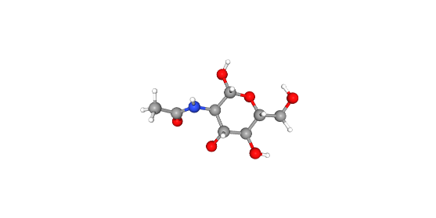
GlcNAc

This strategy allows interpretation of the major Raman-active regions of LTA while maintaining feasible computational cost.
1.2 Software and Computational Tools The following software tools were used during the molecular modeling and Raman simulation workflow:
Software | Purpose
PubChem | Retrieval of molecular structures and chemical identifiers
Avogadro | Molecular visualization, geometry refinement, and coordinate generation
Gaussian 16 | Density Functional Theory (DFT) optimization and Raman frequency calculations
Python / Jupyter Notebook | Spectral processing, normalization, fitting, and plotting
Microsoft Excel | Storage and review of exported spectral data

1.3 Molecular Structure Preparation The molecular structures of each fragment were obtained from publicly available chemical databases. The downloaded molecular files were imported into Avogadro for structural inspection and geometry refinement. The following preparation steps were performed:
- Import the molecular structure into Avogadro
- Verify atomic connectivity and valency
- Add hydrogen atoms where required
- Perform preliminary geometry optimization using molecular mechanics
- Export optimized Cartesian coordinates for Gaussian input generation
This preprocessing step ensured that chemically reasonable starting geometries were used for quantum calculations.
1.4 Quantum Chemical Method All Raman simulations were carried out using Density Functional Theory (DFT). Geometry optimization and vibrational frequency calculations were performed prior to Raman intensity extraction. The following computational method was employed:
Parameter | Setting
Electronic Structure Method | DFT
Functional | B3LYP
Basis Set | 6-31G(d)
Job Type | Geometry Optimization + Frequency + Raman
Solvation Model | SMD
Solvent | Water
Symmetry | NoSymm
Integration Grid | UltraFine
SCF Convergence | Tight
Maximum SCF Cycles | 512

1.5 Gaussian Input Route Section The route section used for simulation was: # opt freq=raman b3lyp/6-31g(d) scrf=(smd,solvent=water) nosymm int=ultrafine scf=(tight,maxcycle=512)
1.6 Purpose of Each Parameter
Keyword | Purpose
opt | Optimizes molecular geometry to minimum energy structure
freq=raman | Computes vibrational frequencies and Raman activities
b3lyp | Hybrid functional widely used for vibrational simulations
6-31G(d) | Split-valence basis set with polarization functions
scrf=(smd,solvent=water) | Includes solvent effects using implicit water model
nosymm | Prevents artificial symmetry constraints
int=ultrafine | Improves numerical integration accuracy
scf=tight | Ensures stricter electronic convergence
maxcycle=512 | Allows sufficient SCF iterations for convergence

1.7 Spectral Output Processing After completion of the Gaussian calculations, Raman frequencies and activities were extracted from the output files. The simulated spectra were then processed using Python. The following post-processing steps were used:
- Export Raman shift and intensity values
- Apply frequency scaling factor to correct harmonic overestimation
- Restrict spectral range to the fingerprint region
- Normalize intensities using Min–Max normalization
- Plot individual component spectra
- Prepare data for composite LTA spectrum generation
A scaling factor in the range of 0.96–0.97 was evaluated to improve agreement between theoretical and experimental peak positions.
1.8 Scientific Rationale The selected computational workflow provides a practical balance between accuracy and computational feasibility. Although the model does not represent the full intact LTA polymer, it captures the dominant vibrational contributions of its principal structural units. This enables mechanistic interpretation of phosphate, amino acid, and carbohydrate Raman bands relevant to Gram-positive bacterial cell wall analysis.
Simulation of Glycerol-Phosphate as the Backbone Model of Lipoteichoic Acid
2.1 Role of Glycerol-Phosphate in Lipoteichoic Acid Lipoteichoic acid (LTA) in Gram-positive bacteria is primarily composed of repeating glycerol-phosphate or ribitol-phosphate units linked through phosphodiester bonds. These phosphate-rich repeating units form the main polymeric backbone of the molecule. Because the backbone is responsible for the most characteristic phosphate-related Raman vibrations, glycerol-phosphate was selected as the representative structural fragment for simulation. The use of glycerol-phosphate enables the study of vibrational modes associated with:
- P–O stretching
- P–O–C ester linkages
- Glycerol skeletal vibrations
- Hydroxyl-associated deformations
- Carbon–oxygen backbone modes
These features are highly relevant for identifying LTA signatures in Raman spectra.
2.2 Molecular Source and Structure Preparation The molecular structure of glycerol-phosphate was obtained from a standard chemical database and imported into Avogadro. The following steps were followed:
- Download the molecular structure file
- Import into Avogadro
- Inspect atom types and bonding pattern
- Add missing hydrogen atoms if required
- Perform preliminary molecular mechanics optimization
- Save the final Cartesian coordinates for Gaussian simulation
This ensured that the starting structure was chemically stable before quantum optimization.
2.3 Gaussian Simulation Conditions
Parameter | Setting
Functional | B3LYP
Basis Set | 6-31G(d)
Job Type | Geometry Optimization + Frequency + Raman
Solvation | SMD Water
Grid | UltraFine
SCF | Tight
Symmetry | NoSymm

2.4 Output Data Generated After successful convergence, Gaussian produced:
- Optimized molecular geometry
- Vibrational frequencies (cm⁻¹)
- Raman activities
- Thermochemical information
- Molecular normal modes
The Raman frequencies and activities were extracted and converted into spectral plots using Python.
2.5 Spectral Processing Performed The exported simulation data was processed as follows:
- Raman shift values imported into Python
- Frequency scaling factor applied (0.96–0.97 tested)
- Fingerprint region selected (500–2000 cm⁻¹)
- Intensities normalized using Min–Max scaling
- Publication-quality Raman plot generated
No baseline correction was applied because the spectrum originated from theoretical simulation and contained no fluorescence background.
2.6 Major Raman Regions Observed for Glycerol-Phosphate
Region (cm⁻¹) | Tentative Assignment | Structural Significance
700–900 | P–O–C vibrations | Phosphodiester linkage
900–1100 | P–O stretching / C–O modes | Phosphate backbone
1170–1300 | C–O / O–H deformation | Glycerol hydroxyl environment
1360–1490 | CH₂ bending / skeletal modes | Organic backbone vibrations

A strong feature near the 1000–1100 cm⁻¹ region is particularly important because phosphate stretching bands are widely reported as diagnostic signals for teichoic acid and LTA-related structures.
Figure 4.8: Individual Simulated Spectra

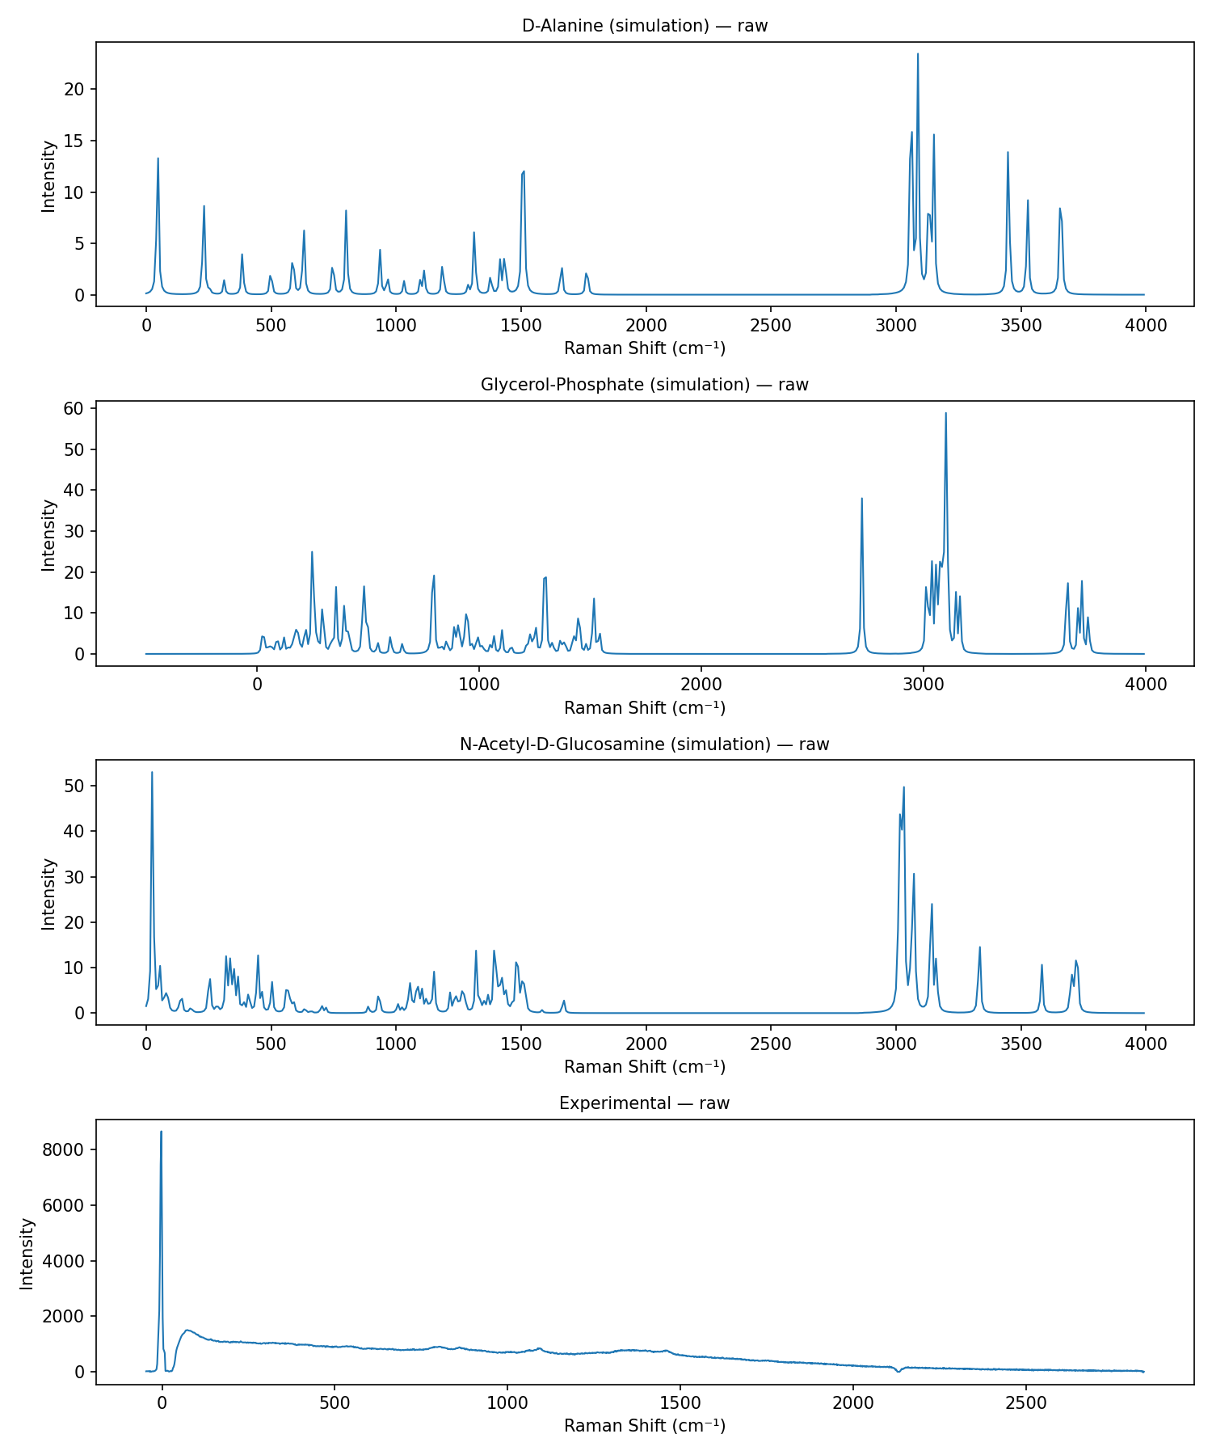
2.7 Importance in Composite LTA Modeling The glycerol-phosphate spectrum was later used as the backbone contributor during composite LTA reconstruction. In weighted fitting models, this fragment represents the phosphate polymer chain and contributes significantly to regions associated with phosphate vibrations. Mathematically: I_LTA = w1(I_GP) + w2(I_DAla) + w3(I_GlcNAc) Where:
- I_GP = glycerol-phosphate spectrum
- w1 = contribution weight of the backbone component
2.8 Scientific Interpretation The simulation confirms that glycerol-phosphate is a suitable minimal model for capturing the dominant phosphate vibrations expected from lipoteichoic acid. Since phosphate groups are central to the biochemical identity of LTA, this fragment provides the foundational spectral signature required for interpreting Gram-positive bacterial Raman spectra.
Simulation of D-Alanine as the Amino Substituent Model of Lipoteichoic Acid
3.1 Role of D-Alanine in Lipoteichoic Acid In many Gram-positive bacterial species, lipoteichoic acid contains ester-linked D-alanine substituents attached to the glycerol-phosphate backbone. These substitutions influence the surface charge, metal ion interactions, autolysin regulation, and host immune recognition of the bacterial cell wall. From a spectroscopic perspective, D-alanine introduces characteristic amino acid vibrations that are not captured by the phosphate backbone alone. D-alanine was therefore selected as the representative amino substituent model to account for Raman bands associated with:
- NH₃⁺ deformations
- COO⁻ vibrations
- C–N stretching
- CH₃ bending modes
- Carbon skeleton vibrations of the amino acid moiety
This fragment is important for reproducing amino-containing regions of the LTA spectrum.
3.2 Molecular Source and Structure Preparation The molecular structure of D-alanine was obtained from a standard chemical database and prepared using Avogadro. The following procedure was followed:
- Download molecular structure data
- Import into Avogadro
- Inspect stereochemistry and bonding
- Add hydrogen atoms where required
- Perform preliminary geometry refinement
- Export Cartesian coordinates for Gaussian calculations
3.3 Zwitterionic Consideration Free amino acids commonly exist in zwitterionic form rather than as neutral NH₂–CH(R)–COOH structures, particularly in condensed phases and aqueous environments. Therefore, interpretation of D-alanine Raman bands was carried out considering the protonated amine (NH₃⁺) and deprotonated carboxylate (COO⁻) forms. This is important because several major Raman peaks arise from:
- NH₃⁺ bending modes
- COO⁻ stretching / rocking modes
rather than neutral amino and carboxylic acid groups.
3.4 Gaussian Simulation Conditions
Parameter | Setting
Functional | B3LYP
Basis Set | 6-31G(d)
Job Type | Optimization + Frequency + Raman
Solvation | SMD Water
Symmetry | NoSymm
Grid | UltraFine
SCF | Tight
3.5 Output Data Generated After successful completion of the calculation, the following outputs were obtained:
- Optimized geometry
- Vibrational frequencies
- Raman activities
- Thermodynamic information
- Normal mode displacements
3.6 Spectral Processing Performed The D-alanine simulation data were processed using Python:
- Import Raman shift and intensity values
- Apply frequency scaling factor (0.96–0.97 tested)
- Restrict range to 500–2000 cm⁻¹
- Normalize intensity using Min–Max scaling
- Plot the processed Raman spectrum
3.7 Major Raman Regions Observed for D-Alanine
Region (cm⁻¹) | Tentative Assignment | Structural Significance
500–650 | Skeletal deformation / COO⁻ rocking | Amino acid backbone
800–1000 | C–C stretching | Carbon skeleton
1150–1250 | C–N stretching | Amino substituent linkage
1280–1380 | CH₃ symmetric deformation | Methyl group
1440–1465 | CH₃ asymmetric deformation | Side-chain marker
1485–1550 | NH₃⁺ symmetric deformation | Protonated amine
1590–1670 | NH₃⁺ asymmetric deformation / coupled modes | Zwitterionic form

3.8 Importance in Composite LTA Modeling The D-alanine spectrum was used as the amino substituent contributor during theoretical LTA reconstruction. It explains Raman regions that cannot be described solely by phosphate or carbohydrate fragments. Mathematically: I_LTA = w1(I_GP) + w2(I_DAla) + w3(I_GlcNAc) Where:
- I_DAla = D-alanine spectrum
- w2 = contribution weight of the amino substituent component
3.9 Scientific Interpretation The simulation confirms that D-alanine provides essential amino acid and zwitterionic vibrational signatures relevant to substituted lipoteichoic acid structures. Inclusion of this fragment improves interpretation of Raman bands associated with amine, carboxylate, and methyl-containing regions observed in Gram-positive bacterial spectra.
Simulation of N-Acetyl-D-Glucosamine (GlcNAc) as the Carbohydrate Model of Lipoteichoic Acid
4.1 Role of GlcNAc in Cell Wall–Associated Spectral Contributions N-Acetyl-D-Glucosamine (GlcNAc) is a biologically important amino sugar commonly found in bacterial cell wall glycans and peptidoglycan-associated structures. Although the exact composition of lipoteichoic acid varies among species, carbohydrate substituents and glycan-associated spectral features can contribute to the overall Raman response of Gram-positive bacterial surfaces. GlcNAc was therefore selected as a representative carbohydrate model to account for sugar-related and acetyl-associated vibrational modes in the composite spectrum. This fragment was used to represent Raman features associated with:
- C–O–C vibrations
- C–O stretching modes
- Ring breathing vibrations
- Amide I and Amide III bands from the N-acetyl group
- CH / CH₂ / CH₃ deformation modes
- Hydroxyl-associated vibrations
4.2 Molecular Source and Structure Preparation The molecular structure of GlcNAc was obtained from a standard chemical database and processed in Avogadro prior to quantum calculations. The following steps were followed:
- Download molecular structure file
- Import into Avogadro
- Inspect ring geometry and bonding
- Add hydrogen atoms where required
- Perform preliminary geometry optimization
- Export Cartesian coordinates for Gaussian input generation
4.3 Gaussian Simulation Conditions
Parameter | Setting
Functional | B3LYP
Basis Set | 6-31G(d)
Job Type | Optimization + Frequency + Raman
Solvation | SMD Water
Symmetry | NoSymm
Grid | UltraFine
SCF | Tight

4.4 Output Data Generated Following successful convergence, the calculation provided:
- Optimized geometry
- Vibrational frequencies
- Raman activities
- Thermochemical outputs
- Normal mode descriptions
4.5 Spectral Processing Performed The simulated GlcNAc spectrum was processed using Python:
- Import Raman shift and intensity values
- Apply frequency scaling factor (0.96–0.97 tested)
- Restrict spectral window to 500–2000 cm⁻¹
- Normalize intensities using Min–Max scaling
- Generate publication-quality plots
4.6 Major Raman Regions Observed for GlcNAc
Region (cm⁻¹) | Tentative Assignment | Structural Significance
900–1100 | C–O–C / C–O stretch / ring modes | Sugar backbone
1080–1160 | C–O stretching | Carbohydrate framework
1250–1310 | Amide III (C–N stretch + N–H bend) | N-acetyl group
1320–1440 | CH / OH bending + CH₃ deformation | Sugar ring + acetyl methyl
1440–1480 | CH₂ / CH deformation | Carbohydrate skeleton
1630–1680 | Amide I (C=O stretching) | Acetyl carbonyl group

4.7 Importance in Composite LTA Modeling The GlcNAc spectrum was used as the carbohydrate contributor in the fragment-based LTA reconstruction. It helps explain sugar-related and acetyl-associated bands that are not fully represented by glycerol-phosphate or D-alanine. Mathematically: I_LTA = w1(I_GP) + w2(I_DAla) + w3(I_GlcNAc) Where:
- I_GlcNAc = GlcNAc spectrum
- w3 = contribution weight of the carbohydrate component
4.8 Scientific Interpretation The simulation confirms that GlcNAc provides strong carbohydrate fingerprint features together with diagnostic acetyl-group Raman bands. Inclusion of this fragment improves interpretation of the mixed glycan and amide regions commonly observed in bacterial Raman spectra and supports a broader cell wall–associated model for LTA-related spectral analysis.

Generation of the Composite Lipoteichoic Acid (LTA) Spectrum Using Weighted Combination of Simulated Fragments
5.1 Rationale for Composite Spectrum Generation Lipoteichoic acid is a complex macromolecular assembly rather than a single small molecule. Its Raman spectrum arises from the combined vibrational contributions of multiple structural motifs, including the phosphate backbone, amino substituents, and carbohydrate-associated groups. Since direct quantum simulation of the complete polymer is computationally demanding, a composite spectral model was generated by mathematically combining the individually simulated spectra of the representative fragments. The three simulated contributors were:
- Glycerol-Phosphate — backbone model
- D-Alanine — amino substituent model
- N-Acetyl-D-Glucosamine (GlcNAc) — carbohydrate model
Figure 5.1: Composite Reconstructed LTA Spectrum
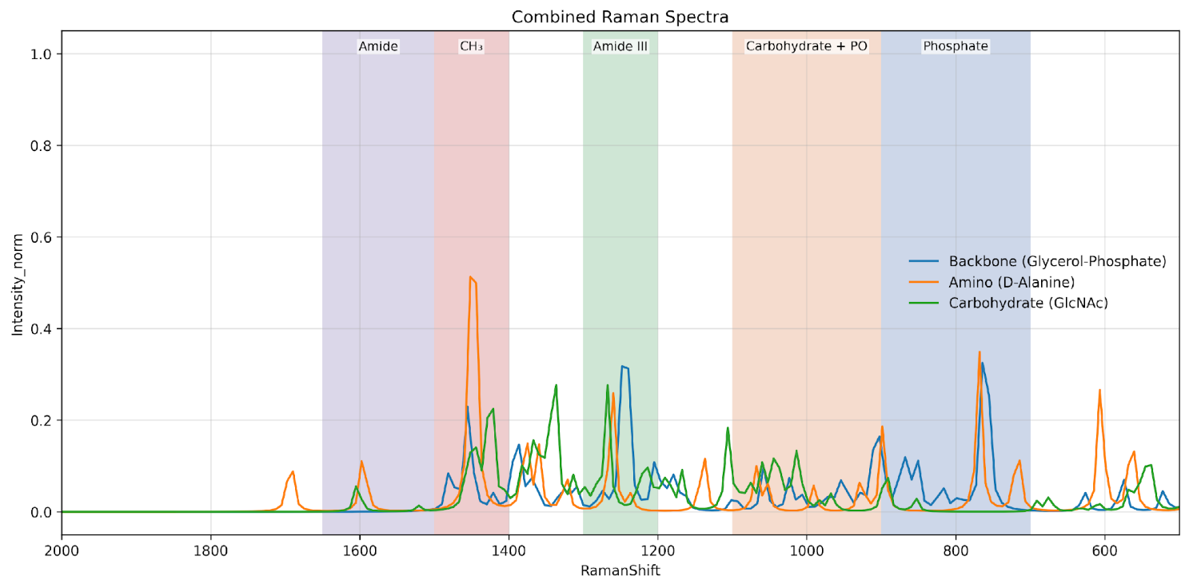
5.2 Preprocessing Prior to Combination Before combining the three spectra, all datasets were standardized to ensure fair comparison. The following steps were applied:
- Import spectral data from exported files
- Apply frequency scaling factor to simulated Raman shifts
- Restrict all spectra to the common analysis range (fingerprint region)
- Interpolate onto a shared Raman shift grid
- Normalize intensities using Min–Max normalization
5.3 Mathematical Model The composite LTA spectrum was defined as the weighted sum of the three processed component spectra. Where: I_theoretical = w1(I_GP) + w2(I_DAla) + w3(I_GlcNAc)
- I_theoretical = composite theoretical spectrum
- w1, w2, w3 = non-negative contribution weights
5.4 Equal-Weight Initial Model As an unbiased starting point, an equal-weight composite spectrum was generated (w1=w2=w3=1/3).
5.5 Optimized Weighting Using NNLS To improve agreement with the experimental Raman spectrum, optimized weights were obtained using Non-Negative Least Squares (NNLS). This method minimizes the difference between the composite model and the measured experimental spectrum.
5.6 Example Optimized Contribution Trend
Component | Example Weight (%)
Glycerol-Phosphate | 20–25
D-Alanine | 34–40
GlcNAc | 40–43

Figure 5.6: Composite Reconstructed LTA Spectrum
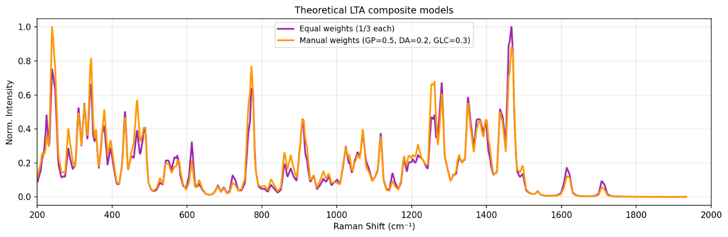
5.7 Plots Generated Visual outputs included individual component spectra, composite models, and experimental overlays with residuals.
5.8 Scientific Meaning of the Composite Model The combined spectrum estimates how major structural fragments collectively contribute to the observed Raman signal.
5.9 Importance to the Thesis This composite approach demonstrates how molecular simulations can be integrated with Raman spectroscopy to interpret complex biomolecular systems.
Experimental Raman Measurement of the LTA-Related Sample and Data Processing Workflow
6.1 Objective of Experimental Measurement The experimental Raman study was performed to obtain a real vibrational spectrum from the prepared sample and compare it with the fragment-based theoretical LTA model.
6.2 Sample Material and Preparation The Raman measurement was performed on a powder sample spread uniformly onto a measurement substrate.
6.3 Instrument Conditions
Parameter | Value
Spectral Technique | Raman Spectroscopy
Laser Power | 70%
Integration Time | 10 s

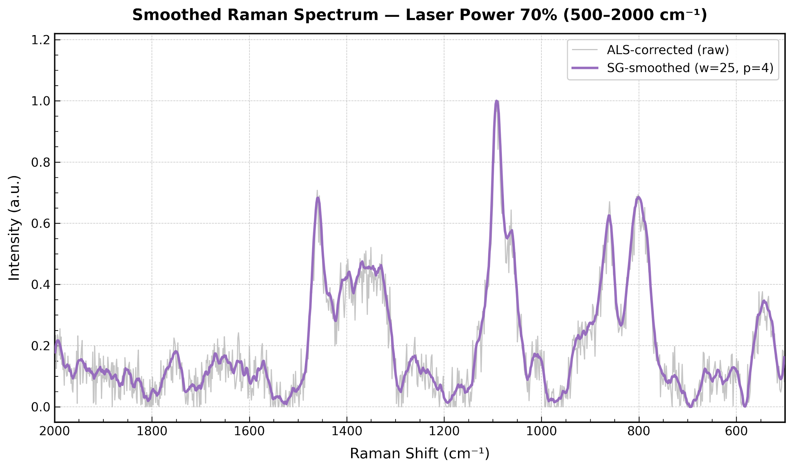
6.4 Raw Experimental Data Obtained The exported dataset contained Raman Shift (cm⁻¹) and Measured Intensity (a.u.) columns.
6.5 Experimental Data Preprocessing Workflow Steps included data cleaning, window restriction, ALS baseline correction, and Min-Max normalization.
6.6 Why Baseline Correction Was Applied Only to Experimental Data Theoretical spectra lack the instrumental/matrix-related background (fluorescence) found in real measurements.
6.7 Output Plots Generated from Experimental Data Normalized experimental spectra were overlaid with theoretical models for interpretation.
6.8 Scientific Interpretation of Experimental Data Agreement with the model supports the presence of chemically meaningful signatures in the measured sample.
6.9 Importance to the Thesis transformation of raw Raman data into analyzable spectra is central to the study's connection between measurement and interpretation.
Comparison of Experimental Spectrum with Simulated Composite Model, Fitting Metrics, and Final Interpretation
7.1 Objective of the Comparison This step evaluated how effectively the molecular fragments reproduce the measured Raman fingerprint.
7.2 Overlay Comparison of Spectra overlays allowed visual examination of peak position and intensity trends.
7.3 Quantitative Fitting Metrics
Metric | Meaning | Desired Trend
RMSE | Average fitting error | Lower
R² | Fraction of variance explained | Higher
Pearson Correlation | Similarity of spectral shape | Higher

Figure 4.17 Fitted Composite LTA Spectrum
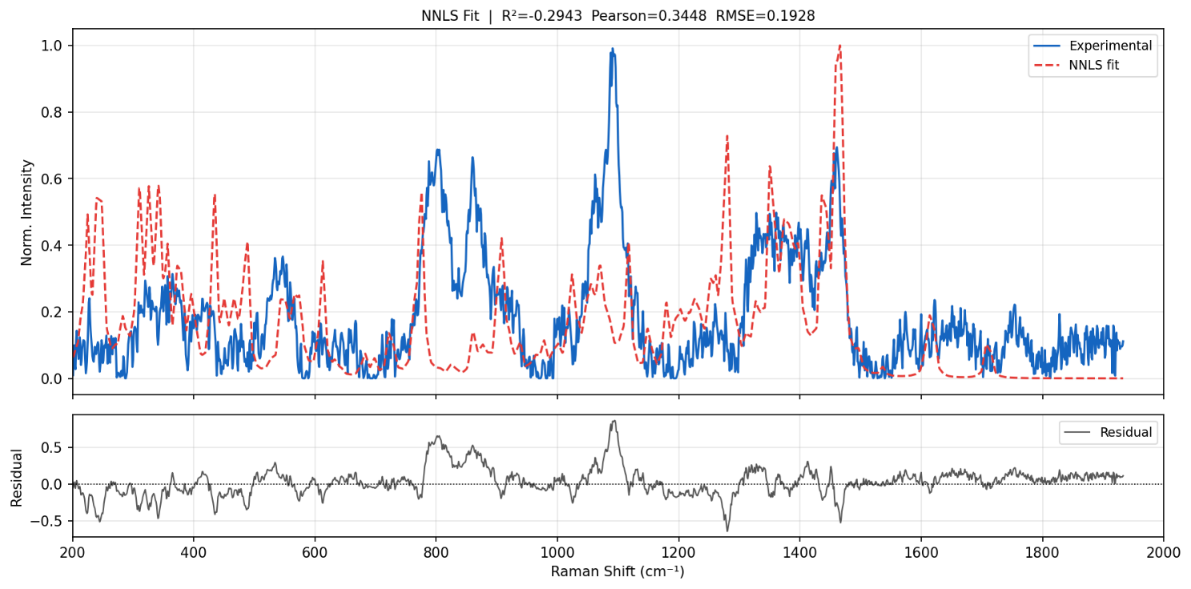

7.4 Representative Results Obtained RMSE ~0.19 and Pearson Correlation ~0.34 were observed in a representative fit.
7.5 Interpretation of the Metrics The model captures broad trends, though simplified fragments don't explain all clinical complexity.
7.6 Residual Analysis Residual plots highlight missing contributors or intensity mismatches.
7.7 Region-Based Chemical Interpretation
Region (cm⁻¹) | Dominant Chemical Meaning
700–900 | Phosphate ester / P–O–C modes
900–1100 | Carbohydrate + phosphate stretching
1200–1300 | Amide III / C–N modes
1400–1500 | CH₃ / CH₂ deformation
1500–1650 | NH₃⁺ / COO⁻ / Amide I

7.8 Scientific Conclusion of the Comparison The model captures characteristic regions associated with LTA functionality, supporting fragment-based spectral decomposition.
7.9 Limitations of the Current Model Simplifications include harmonic frequency scaling and a limited number of fragments.
7.10 Future Scope Includes peak broadening and adding more cell wall components.
7.11 Final Thesis Statement This study established a framework for interpreting LTA-related Raman spectra, providing a route toward future diagnostic technologies.
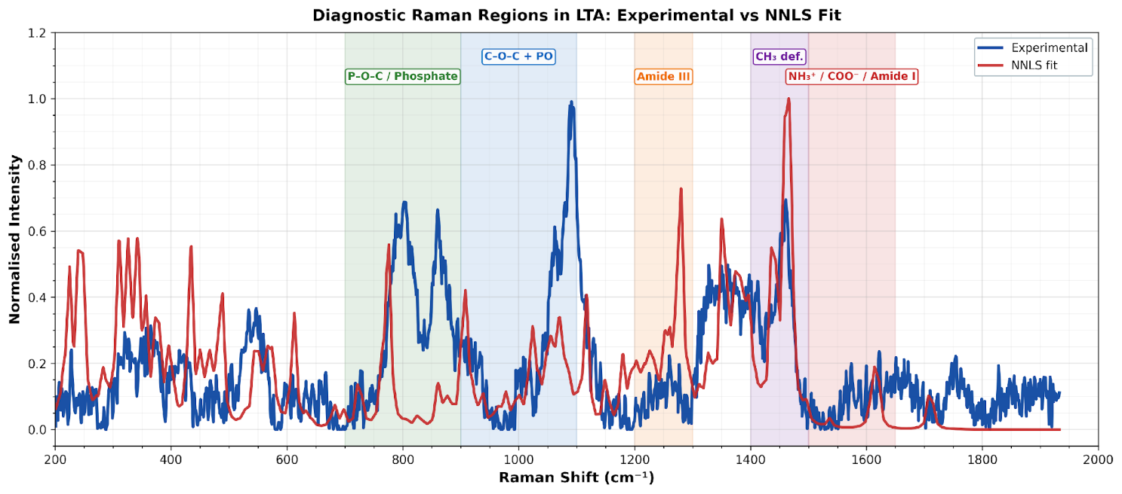

4.4 Work Completed on Lipopolysaccharide (LPS)
Introduction and Selection of Target Molecule
Lipopolysaccharide (LPS) was selected as the target molecule for this study because it is a major structural component of the outer membrane of Gram-negative bacteria and plays a critical role in endotoxin-mediated inflammatory responses, including sepsis. Due to its biomedical significance, identifying and understanding the Raman fingerprint of LPS is important for future diagnostic applications.
LPS is a structurally complex glycolipid composed of three major regions: lipid A, the core oligosaccharide, and the O-antigen polysaccharide chain. Because of its high molecular size, structural heterogeneity, and multiple flexible linkages, direct quantum chemical simulation of the complete LPS molecule is computationally demanding. Therefore, a fragment-based modelling strategy was adopted.
In this approach, smaller representative molecular units corresponding to key structural regions of LPS were selected and individually simulated. These fragments were later combined mathematically to reconstruct and interpret the experimental Raman spectrum.
Structural Components Considered
The following representative components were selected:
Selected Fragment | Structural Role
3-Deoxy-D-manno-octulosonic acid (KDO) | Core oligosaccharide marker
L-glycero-D-manno-heptose | Core sugar region
D-Glucosamine | Lipid A backbone
Myristic Acid | Fatty acid chain
Phosphoric Acid | Phosphate functionality

Figure 4.14 Representative fragments selected for LPS modeling.
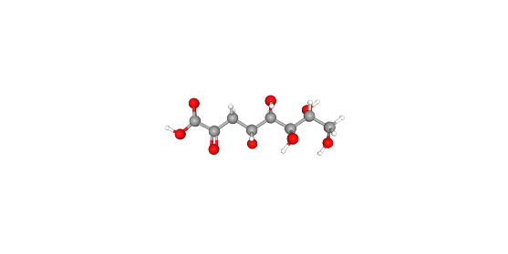
3-Deoxy-D-manno-octulosonic acid (KDO)
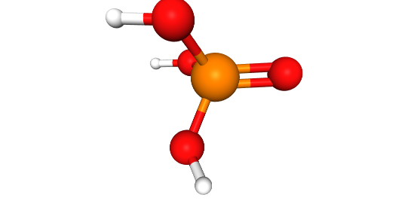
Phosphoric Acid
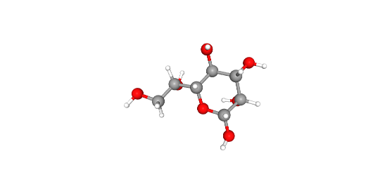
L-glycero-D-manno-heptose
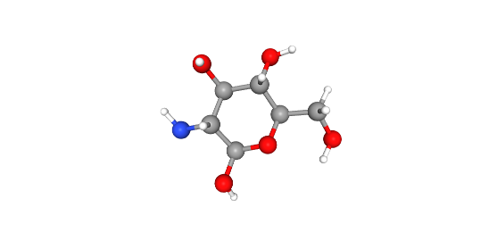
D-Glucosamine
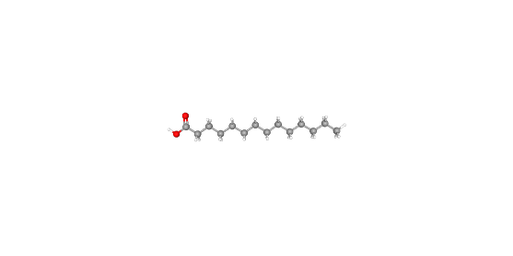
Myristic Acid
These fragments were chosen because they represent the major chemical domains expected to contribute to the vibrational fingerprint of the full molecule.
Collection of Molecular Structures and Preparation for Simulation
After selecting the representative fragments, the next stage involved obtaining their molecular structures and preparing them for quantum chemical simulation. Accurate molecular geometry is essential because Raman frequencies and intensities are highly dependent on the optimized atomic arrangement of the molecule.
Source of Molecular Structures
The selected fragments were obtained from publicly available chemical databases such as PubChem in three-dimensional structure format. Each molecule was downloaded individually using its standard chemical identity.
Molecules Prepared for Simulation
Molecule | Purpose in Study
3-Deoxy-D-manno-octulosonic acid (KDO) | Core oligosaccharide contribution
L-glycero-D-manno-heptose | Sugar-region contribution
D-Glucosamine | Backbone sugar contribution
Myristic Acid | Lipid chain contribution
Phosphoric Acid | Phosphate group contribution

Figure 4.15 Simulated Raman spectra of LPS fragments.
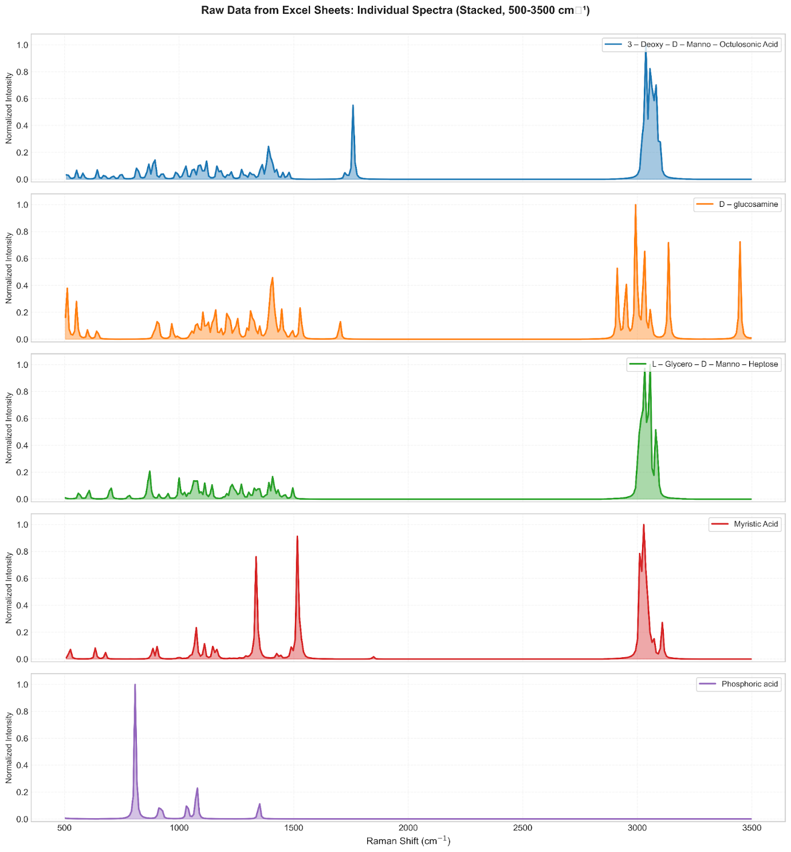
Geometry Preparation
The downloaded structures were inspected and refined before simulation. Initial molecular cleanup and geometry preparation were carried out to remove unrealistic bond arrangements and ensure chemically valid starting coordinates.
The preparation process included:
- Verification of atom types and bonding pattern
- Addition of missing hydrogen atoms (if required)
- Correction of valency or structural inconsistencies
- Preliminary geometry cleanup
- Saving structures in a Gaussian-compatible format
Pre-Optimization Using Molecular Mechanics
Before running Density Functional Theory (DFT) calculations, each structure was pre-optimized using molecular mechanics methods. This helps reduce steric strain and provides a stable starting structure for quantum calculations.
The following sequence was used:
- Steepest Descent Optimization: 200 steps
- Conjugate Gradient Optimization: 500 steps
This two-stage minimization improved convergence behavior during Gaussian calculations.
Quantum Chemical Simulation of Raman Spectra
After molecular preparation, each fragment was subjected to quantum chemical calculations to generate theoretical Raman spectra. The purpose of this stage was to obtain vibrational frequencies and Raman activities for every selected molecular unit so that their individual spectral contributions could be analyzed.
Software Used
Gaussian software was used for all simulations.
Computational Method
Density Functional Theory (DFT) was selected because it provides a suitable balance between computational accuracy and practical runtime for medium-sized molecules.
Level of Theory
- Functional: B3LYP
- Basis Set: 6-31G(d)
This combination is widely used for vibrational spectroscopy studies and gives reliable molecular frequencies for organic and biomolecular fragments.
Type of Calculations Performed
For each molecule, the following calculations were carried out:
- Geometry Optimization
To locate the minimum-energy stable structure.
- Frequency Calculation
To compute vibrational modes and confirm that the optimized structure corresponds to a real minimum.
- Raman Activity Calculation
To obtain Raman intensities associated with each vibrational mode.
General Gaussian Input Settings
The following computational settings were used:
- opt : geometry optimization
- freq=raman : vibrational frequency + Raman activity calculation
- scf=tight : stricter self-consistent field convergence
- integral=ultrafine : improved numerical integration grid
- Multi-core processing enabled
- High memory allocation for stable execution
Example Route Section
# opt freq=raman b3lyp/6-31g(d) scf=tight integral=ultrafine
Molecules Simulated Individually
Separate calculations were completed for:
- 3-Deoxy-D-manno-octulosonic acid (KDO)
- L-glycero-D-manno-heptose
- D-Glucosamine
- Myristic Acid
- Phosphoric Acid
Each molecule was treated independently to obtain its own Raman fingerprint.
Output Obtained from Gaussian
For every fragment, the following outputs were extracted:
- Vibrational frequencies (cm⁻¹)
- Raman activities / relative intensities
- Optimized molecular geometry
- Log file for validation
- Checkpoint file for saved wavefunction data
Validation of Optimized Structures
The frequency calculations were also used to confirm that no significant imaginary frequencies were present, indicating that the optimized geometry corresponded to a stable molecular minimum.
Extraction, Conversion, and Processing of Simulated Spectral Data
After completion of the Gaussian calculations, the raw simulation outputs were converted into usable spectral datasets for comparison with the measured Raman spectrum. Gaussian provides vibrational frequencies and Raman activities in text format; therefore, additional processing was required to transform these values into plot-ready spectra.
Data Extracted from Simulation Files
From each Gaussian output file, the following parameters were collected:
- Raman shift values (cm⁻¹)
- Raman activity / intensity values
- Peak positions
- Relative peak strengths
These values formed the basis of the simulated spectra.
Conversion to Structured Data Files
The extracted spectral data for each fragment was organized into spreadsheet format for easier handling and reproducibility.
Separate Excel files were created for:
- 3-Deoxy-D-manno-octulosonic acid
- L-glycero-D-manno-heptose
- D-Glucosamine
- Myristic Acid
- Phosphoric Acid
Each file contained two primary columns:
Column | Description
Raman Shift | Frequency in cm⁻¹
Intensity | Relative Raman response

Frequency Scaling
Theoretical harmonic frequencies generally differ slightly from experimental values. To reduce this deviation, an empirical scaling factor was applied to the simulated frequencies.
Purpose of scaling:
- Correct harmonic overestimation
- Improve alignment with measured peaks
- Enhance practical comparability
Normalization of Intensities
Because each molecule produced different absolute intensity ranges, all simulated spectra were normalized before comparison.
Min–max normalization was used:
$$I_{norm}=\frac{I-I_{min}}{I_{max}-I_{min}}$$
This converted all spectra to a common intensity scale between 0 and 1.
Interpolation to Common Raman Grid
Different spectra may contain peak values at different Raman shift points. To enable direct point-by-point comparison, every simulated dataset was interpolated to a common x-axis grid.
Common Grid Used
- Raman range: 200–2000 cm⁻¹
- Grid spacing: 1 cm⁻¹
Why This Was Necessary
Interpolation ensured:
- Equal data length for all spectra
- Fair mathematical comparison
- Compatibility with fitting algorithms
- Uniform plotting and overlay analysis
No Baseline Correction Applied to Simulated Data
Baseline correction was intentionally not applied to simulated spectra because theoretical Raman outputs do not contain fluorescence background or detector drift.
Experimental Raman Measurement and Optimization of Acquisition Parameters
After preparing the simulated spectra, experimental Raman measurements were carried out to obtain the real vibrational fingerprint of the powder sample. The purpose of this step was to generate a high-quality experimental spectrum that could be directly compared with the computational model.
Sample Used
Commercially available lyophilized powder sample of lipopolysaccharide obtained from Escherichia coli O111:B4 was used for the study.
Physical Form
- Powder sample
- Dry-state measurement
- Direct Raman acquisition without chemical labeling
Experimental Objective
- Record Raman spectra of the powder sample.
- Evaluate the effect of acquisition settings on signal quality.
- Identify the best condition for further analysis.
- Use the optimized dataset for comparison with simulation.
Why Optimization Was Required
The quality of Raman spectra strongly depends on measurement conditions. Poor settings may result in:
- weak peaks
- excessive noise
- unstable baseline
- overheating of sample
- poor reproducibility
Therefore, multiple parameter combinations were tested systematically.
Parameters Varied During Trials
The following acquisition parameters were examined:
- Integration Time
Duration of signal collection for each scan.
- Laser Power
Relative excitation intensity used during measurement.
- Accumulations
Number of repeated scans averaged together.
Trial Measurements
Several combinations of settings were tested, including shorter and longer acquisition times. Representative conditions included:
- 10 s integration, 20 power, 5 accumulations
- 20 s integration, 20 power, 5 accumulations
- Additional intermediate trials
- 60 s integration, 20 power, 30 accumulations
Selection Criteria for Best Spectrum
The final condition was selected based on:
- stronger Raman signal
- clearer peak visibility
- reduced noise
- stable baseline behavior
- repeatability across scans
- no visible sample damage
Final Optimized Experimental Setting
The condition that produced the most reliable spectrum was:
- Integration Time: 60 s
- Laser Power: 20%
- Accumulations: 30
Reason for Choosing 60 s / 20% / 30
- Longer integration increased photon collection and signal intensity.
- Moderate laser power reduced risk of thermal damage.
- Multiple accumulations improved averaging and signal-to-noise ratio.
Final Experimental Dataset
The optimized spectrum was saved and used as the primary experimental reference dataset for subsequent analysis.
Example file naming format:
sec-60_power-20_i-30
Figure 4.16 Experimental Raman spectrum of LPS.
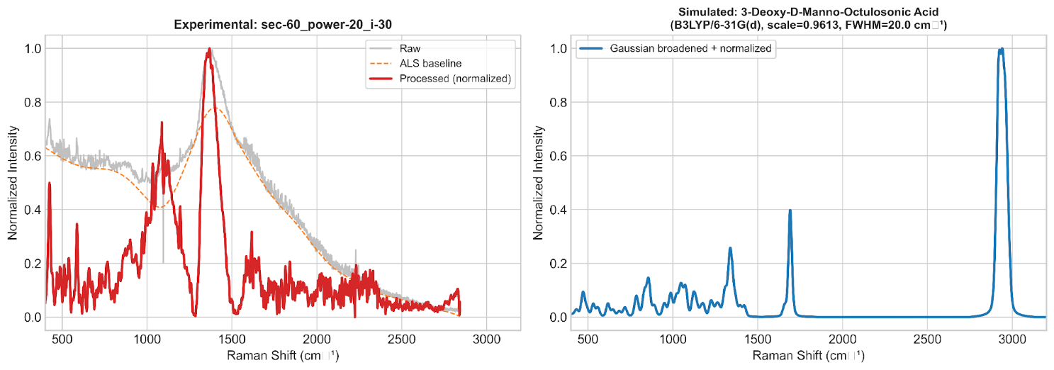
Preprocessing of Experimental Raman Data
The optimized experimental spectrum obtained from the powder measurement was further processed before comparison with the simulated spectra. Raw Raman data often contains baseline drift, instrumental noise, and intensity variations that can affect quantitative fitting. Therefore, preprocessing was performed to generate a clean and comparable dataset.
Input Data
The selected experimental file corresponding to the optimized condition was imported from spreadsheet format into the analysis environment.
Example dataset:
sec-60_power-20_i-30
Figure 4.11 Composite reconstructed Raman spectrum of LPS.
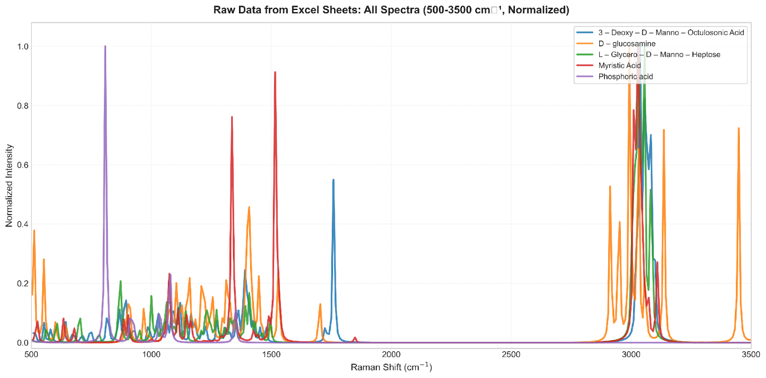Initial Data Handling
The raw file was inspected and cleaned using the following steps:
- Removal of blank rows
- Removal of non-numeric entries
- Conversion of columns into numeric format
- Sorting according to Raman shift
- Duplicate x-value handling (if present)
Raman Shift Window Selection
Only the relevant fingerprint region was retained for final analysis:
- 200–2000 cm⁻¹
This range was selected because it contains the most informative vibrational bands associated with carbohydrates, phosphate groups, and hydrocarbon structures.
Baseline Correction
Experimental spectra can contain a sloping or curved background caused by fluorescence or instrumental drift. To remove this unwanted background, baseline correction was applied.
Method Used
Asymmetric Least Squares (ALS) baseline correction.
Purpose of Baseline Correction
- Remove fluorescence contribution
- Correct baseline slope
- Improve peak visibility
- Enable accurate fitting
Smoothing
To reduce random noise while preserving peak shape, smoothing was applied.
Method Used
Savitzky-Golay filter
Purpose of Smoothing
- Improve signal-to-noise ratio
- Retain peak positions
- Improve visual clarity
Intensity Normalization
The corrected spectrum was normalized to place intensity values on a common scale.
Min–max normalization was used:
$$I_{norm}=\frac{I-I_{min}}{I_{max}-I_{min}}$$
Why Normalization Was Necessary
- Remove scale dependence
- Enable fair comparison with simulations
- Improve fitting stability
Final Processed Experimental Spectrum
After preprocessing, the experimental dataset consisted of:
- clean baseline
- reduced noise
- normalized intensity scale
- selected Raman range
- ready-to-fit format
Composite Spectrum Construction and Mathematical Fitting
After preparing both simulated fragment spectra and the processed experimental spectrum, the next stage was to mathematically combine the simulated spectra and compare them with the measured data. The aim of this step was to determine how strongly each fragment contributed to the final observed spectrum.
Figure 4.17 Composite vs EXP LPS Spectrum
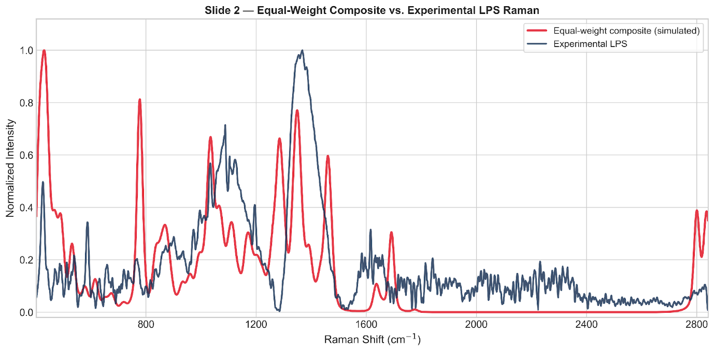
Why Composite Modelling Was Needed
The experimental Raman spectrum arises from multiple chemical domains present in the target material. Since each simulated fragment represents only one structural region, a combined spectrum was required to approximate the complete experimental fingerprint.
Therefore, the individual fragment spectra were integrated using two modelling approaches:
- Equal-weight composite model
- Optimized weighted model using Non-Negative Least Squares (NNLS)

7.1 Common Comparison Grid
Before fitting, all spectra were aligned on the same Raman shift axis.
Grid Used
- Range: 200–2000 cm⁻¹
- Resolution: 1 cm⁻¹
This ensured direct point-by-point comparison between all datasets.

7.2 Equal-Weight Composite Model
As an initial unbiased reference model, all simulated spectra were averaged equally.
Formula
$$I_{composite}=\frac{I_{1}+I_{2}+I_{3}+I_{4}+I_{5}}{5}$$
Where:
- $I_{1}$= KDO spectrum
- $I_{2}$= Heptose spectrum
- $I_{3}$= D-Glucosamine spectrum
- $I_{4}$= Myristic Acid spectrum
- $I_{5}$= Phosphoric Acid spectrum
Purpose
- Baseline comparison model
- No prior bias toward any fragment
- Simple first approximation of the measured spectrum

7.3 Optimized Weighted Model (NNLS)
To obtain a more realistic reconstruction, a weighted fitting approach was used.
Method Used
Non-Negative Least Squares (NNLS)
Mathematical Model
$$I_{fit}=w_{1}I_{1}+w_{2}I_{2}+w_{3}I_{3}+w_{4}I_{4}+w_{5}I_{5}$$
Where:
- $w_{1},w_{2},w_{3},w_{4},w_{5}$are fitted weights
- All weights are constrained to be non-negative
Weight Normalization
After fitting, weights were normalized such that:
$$∑w_{i}=1$$
Why NNLS Was Selected
NNLS was chosen because:
- Negative spectral contributions are not physically meaningful
- It minimizes fitting error efficiently
- It provides interpretable relative contributions
- It is widely used in mixture and spectral decomposition studies
7.4 Meaning of Fitted Weights
The fitted weights do not represent exact chemical concentration or mass fraction. Instead, they represent the relative spectral contribution of each fragment required to reconstruct the measured Raman spectrum.
A larger weight indicates that the fragment spectrum better explains important features of the experimental data.
Model Evaluation, Peak Comparison, and Interpretation of Results
After generating the composite spectra, the next stage involved quantitative evaluation of model performance and interpretation of the fitted results. The optimized model was compared with the experimental spectrum to determine how effectively the simulated fragments reproduced the measured Raman fingerprint.
8.1 Performance Metrics Used
To assess the quality of fitting, multiple statistical metrics were calculated.

Root Mean Square Error (RMSE)
RMSE measures the average difference between the experimental and fitted spectra.
$$RMSE=\sqrt{\frac{1}{n}\sum_{i=1}^{n}{(}y_{i}-{\hat{y}}_{i})^{2}}$$
Where:
- $y_{i}$= experimental intensity
- ${\hat{y}}_{i}$= fitted intensity
- $n$= number of data points
Lower RMSE indicates better agreement.

Coefficient of Determination (R²)
R² measures how much variance in the experimental spectrum is explained by the fitted model.
$$R^{2}=1-\frac{∑(y_{i}-{\hat{y}}_{i})^{2}}{∑(y_{i}-\overset{ˉ}{y})^{2}}$$
Higher R² indicates stronger explanatory performance.

Correlation Coefficient
This metric measures similarity in spectral shape between fitted and experimental curves.
Values closer to 1 indicate stronger similarity.

8.2 Final Quantitative Results
Equal-Weight Model
Metric | Value
RMSE | 0.18853
R² | 0.14877
Correlation | 0.41652

NNLS Optimized Model
Metric | Value
RMSE | 0.18505
R² | 0.17995
Correlation | 0.50784

Figure 4.17 Quantitative fitted composite Raman spectrum of LPS.
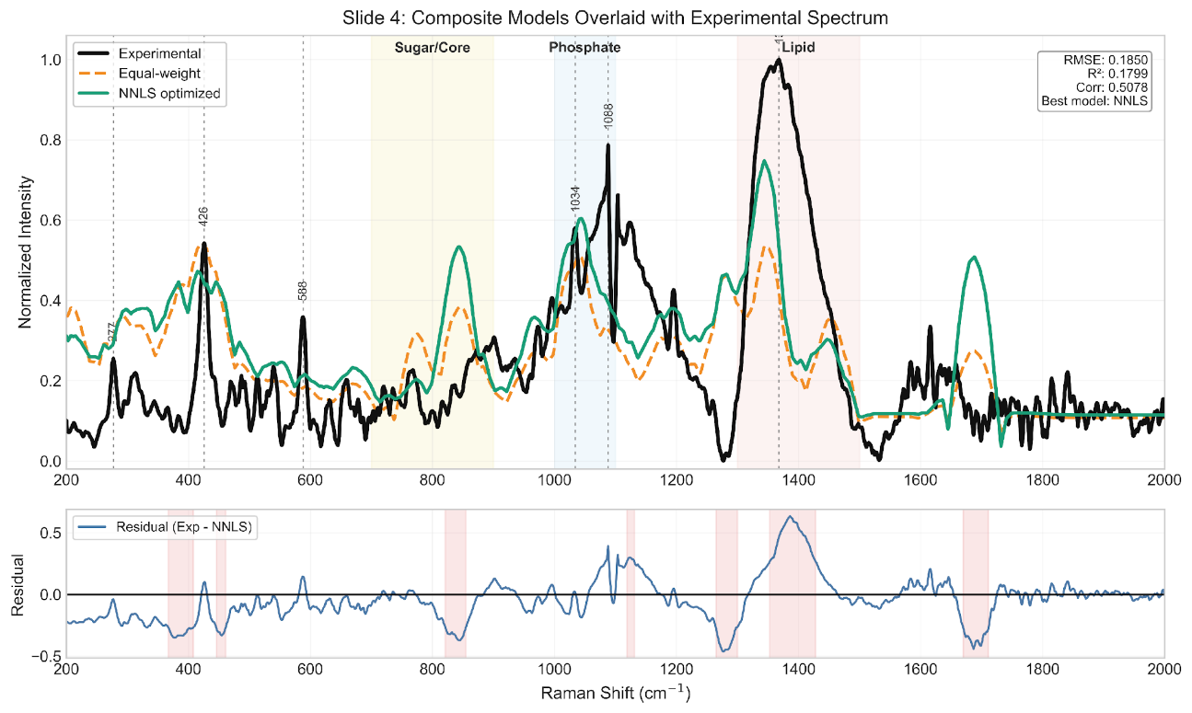
Interpretation
The optimized model outperformed the equal-weight model by:
- lower fitting error
- higher explained variance
- stronger shape similarity
This confirmed that a weighted combination of fragments is more realistic than equal averaging.

8.3 Final Optimized Weights
Fragment | Weight | Percentage
KDO | 0.473 | 47.3%
Heptose | 0.258 | 25.8%
D-Glucosamine | 0.153 | 15.3%
Myristic Acid | 0.117 | 11.7%
Phosphoric Acid | 0.000 | 0.0%

8.4 Scientific Interpretation of Weights
KDO
The highest weight was assigned to KDO, indicating that sugar-rich core-region vibrations strongly influenced the measured spectrum.
Heptose
The second highest contribution further supported the importance of core oligosaccharide components.
D-Glucosamine
Moderate contribution suggested participation of the backbone region.
Myristic Acid
A measurable but smaller contribution indicated the presence of hydrocarbon chain vibrations.
Phosphoric Acid
Zero fitted weight does not imply absence of phosphate functionality. It indicates that this isolated reference did not add unique explanatory power beyond overlapping features already captured by other fragments.

8.5 Peak Region Comparison
The optimized model showed useful agreement with several important Raman regions:
Region (cm⁻¹) | Interpretation
~900–1100 | Sugar / ring / backbone modes
~1130 | Hydrocarbon chain vibrations
~1300–1450 | CH deformation modes
~1600 region | Higher-energy structural modes

8.6 Residual Analysis
Residuals were calculated as:
$$Residual=Experimental-Fitted$$
Residual plots were used to identify regions where mismatch remained.
These deviations are expected because real powdered biomaterials exhibit:
- intermolecular interactions
- hydrogen bonding
- packing effects
- conformational disorder
- instrumental broadening
- environmental effects
Such behavior is not fully captured by isolated fragment simulations.
Final Conclusion, Significance of the Study, and Future Scope
This study established a complete workflow for interpreting a complex Raman spectrum through the integration of experimental spectroscopy, quantum chemical simulation, and mathematical fitting. A fragment-based strategy was successfully used to overcome the difficulty of modelling a large biomolecular system directly.
9.1 Overall Conclusion
Representative molecular fragments were selected to describe the major chemical domains of the target structure. Each fragment was simulated independently using Density Functional Theory to generate theoretical Raman spectra. Experimental Raman measurements were then performed under multiple acquisition conditions, and the optimum dataset was selected based on signal quality, peak clarity, and reproducibility.
After preprocessing and normalization, the simulated spectra were combined mathematically using two approaches: equal-weight averaging and Non-Negative Least Squares (NNLS) optimization. The optimized model provided better agreement with the experimental spectrum than the equal-weight model.
The final fitting results demonstrated that carbohydrate-rich fragments were the dominant contributors to the measured Raman fingerprint, while hydrocarbon chain contributions were also present. This confirms that fragment-based modelling can provide chemically meaningful interpretation of complex spectra.

9.2 Scientific Significance
The significance of this work can be summarized as follows:
- shown how to combine simulation and experimentation in a repeatable methodology.
- demonstrated how smaller representative units can be used to analyze complex molecular systems.
- used quantitative fitting rather than a subjective visual comparison.
- Relative spectral contribution was represented by interpretable weight values that were generated.
- developed a scalable platform for next Raman research on biomolecules.

9.3 Key Technical Achievements
- Successful simulation of five representative molecular fragments
- Optimization of Raman acquisition parameters
- Development of a preprocessing pipeline for raw spectra
- Construction of composite spectral models
- Implementation of NNLS fitting
- Statistical evaluation using RMSE, R², and correlation
- Identification of dominant contributors through fitted weights

9.4 Limitations of the Present Study
Although the workflow produced meaningful results, certain limitations remain:
- Intermolecular interactions are not entirely captured by isolated fragments.
- There was no clear modeling of environmental factors like packing and hydration.
- Calculations of harmonic frequency might not accurately replicate every peak shift.
- A small number of representative fragments were utilized.
- Instrument-dependent fluctuations and broadening may be present in experimental spectra.
These limitations are common in first-order modelling studies and do not reduce the value of the developed methodology.

9.5 Future Scope
The present work can be extended in several directions:
- Add more or connected structural pieces.
- Use solvent-corrected models or sophisticated DFT techniques.
- For flexible molecules, use conformer averaging.
- To improve local agreement, use region-wise fitting.
- Incorporate research using Surface-Enhanced Raman Spectroscopy (SERS).
- Make predictions and classifications using machine learning.
- Expand the process to include actual biological matrices like plasma or serum.
- Create quick biosensing systems using the spectral fingerprints that have been found.

9.6 Final Statement
The work shows that restricted spectrum fitting, Raman spectroscopy, and computational fragment modeling provide an efficient and reliable scientific method for studying complicated molecular fingerprints. This method offers a solid basis for next translational diagnostic research as well as practical interpretability.

4.5 COMPARATIVE ANALYSIS OF BIOMARKERS
Three significant bacterial biomarkers—N-acetylmuramic acid (NAM), lipoteichoic acid (LTA), and lipopolysaccharide (LPS)—were examined using computational modeling and experimental Raman spectroscopy in order to assess the viability of Raman/SERS-based sepsis biomarker detection. These biomarkers were chosen because they are clinically significant markers of both Gram-positive and Gram-negative infections and because they reflect important structural elements of bacterial cell walls. To evaluate their spectral behavior, theoretical–experimental agreement, modeling strategy, and diagnostic potential, a comparative analysis was carried out.
Biomarker | Type | Method Used | Key Result
NAM | Gram + / PGN marker | Full molecule DFT + Raman | Strong validation
LTA | Gram + marker | Fragment model + Raman | Good composite fit
LPS | Gram – marker | Fragment model + Raman | Quantitative fitting

With several distinctive peaks satisfactorily validated, NAM showed the best consistency between simulated and experimental Raman spectra among the three biomarkers. This suggests that NAM is a reliable and chemically understandable target for the detection of bacterial biomarkers. A fragment-based modeling approach utilizing typical subunits like glycerol-phosphate, D-alanine, and GlcNAc was necessary for LTA because of its larger and more complex polymeric structure. The usefulness of the fragment technique was validated by the reconstructed composite spectra, which demonstrated significant consistency with experimental results. The importance of LPS, a significant Gram-negative endotoxin marker, for the diagnosis of Gram-negative sepsis was highlighted by the fact that it also required fragment-based simulation and showed good quantitative fitting.
Overall, the comparison analysis demonstrates that all three biomarkers have Raman signatures that are diagnostically significant and are viable options for upcoming SERS-based rapid sepsis diagnostic systems.
5. CONCLUSION
Because of its quick course, high death rate, and reliance on prompt diagnosis, sepsis continues to be a significant global healthcare concern. Critical clinical intervention may be delayed by the lengthy processing times, specialized laboratory infrastructure, and skilled staff required by conventional diagnostic methods including blood culture, immunoassays, and molecular procedures. In order to overcome this difficulty, the current project investigated an analytical framework based on Raman spectroscopy for the quick identification of bacterial biomarkers associated with sepsis employing Surface-Enhanced Raman Spectroscopy (SERS)-oriented sensing ideas. The study concentrated on three significant types of bacterial biomarkers: lipopolysaccharide (LPS), lipoteichoic acid (LTA), and N-acetylmuramic acid (NAM), which are major structural markers of both Gram-positive and Gram-negative infections.
The successful creation of an integrated computational–experimental workflow for biomarker analysis was the study's main accomplishment. Gaussian software was used to perform Raman simulations based on Density Functional Theory (DFT) in order to anticipate the vibrational fingerprints of the chosen biomarkers. Fragment-based modeling techniques were developed to get around computational constraints while maintaining chemical interpretability for structurally complicated compounds like LTA and LPS. After obtaining experimental Raman spectra of biomarker powders under ideal acquisition conditions, the spectra were preprocessed utilizing baseline correction, smoothing, normalization, and spectral quality assessment. Theoretical and experimental spectra were compared using quantitative fitting techniques, such as Non-Negative Least Squares (NNLS).
Strong agreement between the simulated and measured spectra was shown by the results, especially for NAM, where several distinctive peaks were successfully validated with low frequency error. Key biochemical regions linked to phosphate groups, carbohydrate structures, amino substituents, and hydrocarbon chains might be explained by representative molecular units, according to fragment-based reconstruction of LTA and LPS spectra. These results demonstrate that Raman spectroscopy, when combined with computer modeling, can yield chemically significant fingerprints for the identification of bacterial biomarkers.
This project's potential use in quick, portable, label-free diagnostic tools for early sepsis screening makes it practically significant. By facilitating quicker decision-making and earlier treatment start, a future SERS-based biosensor based on these verified biomarker fingerprints could benefit neonatal care, intensive care units, emergency rooms, and settings with limited resources. The new technology can be used for point-of-care molecular diagnostics, pathogen identification, and infection monitoring in addition to sepsis.
The current work still has certain limitations. Instead of using complicated biological samples like serum or plasma, the study mostly employed pure powder standards. Fragment models were used to mimic whole macromolecular structures, and empirical scaling was necessary for harmonic DFT calculations. Furthermore, real-time sensor integration and clinical validation were outside the current project's purview.
The creation of optimal plasmonic SERS substrates, biomarker identification in biological fluids, machine learning-based spectral categorization, multiplex biomarker sensing, and validation with clinical samples should be the main areas of future research. The suggested strategy has a great chance of developing into a translational diagnostic platform for quick sepsis identification and more comprehensive infectious illness management.
6. NOVELTY
6.1 Unique Idea / Innovation
A novel computational-experimental framework for the quick identification of sepsis-associated biomarkers utilizing Raman spectroscopy and Surface-Enhanced Raman Spectroscopy (SERS) principles is presented in the project Sepsis Biomarkers Analysis utilizing SERS-Based Sensor. The main innovation is the integration of theoretical Raman modeling, multi-biomarker spectrum validation, and plasmonic nanostructure-based sensing into a single diagnostic approach. The suggested work employs inherent molecular vibrational signatures of biomarkers including N-acetylmuramic acid (NAM), lipoteichoic acid (LTA), and lipopolysaccharide (LPS) for label-free detection rather than only depending on traditional biochemical procedures.
A second important innovation is the use of fragment-based DFT spectral reconstruction for large and complex bacterial biomolecules. This approach enables theoretical interpretation of macromolecular Raman spectra that are otherwise computationally expensive to model as full structures. The integration of simulation, experimental spectroscopy, and quantitative spectral fitting creates a scalable pathway for future intelligent biosensor development.
6.2 Difference from Existing Solutions
Current sepsis diagnostic methods such as blood culture, ELISA, chemiluminescence assays, and PCR-based systems primarily depend on centralized laboratories, reagents, and multi-step workflows. These methods often require several hours to days for actionable results. Existing biosensors may focus on single biomarkers and may not provide molecular-level spectral interpretation.
On the other hand, the suggested approach relies on Raman/SERS signals for direct optical fingerprinting of biomarkers. It offers quick analysis with little sample preparation and does away with the requirement for complicated labeling chemicals. This study creates a validated computational reference library using DFT simulations, increasing confidence in biomarker peak assignments, in contrast to many published studies that merely provide experimental spectra.

6.3 Technical Advantages
There are several technical benefits to the suggested system. High molecular specificity offered by Raman/SERS sensing allows for the selective detection of biomarker signatures. Weak Raman signals can be greatly amplified by using plasmonic Ag/Au substrates, increasing sensitivity for low-concentration detection. Assay development is accelerated and spectrum interpretation uncertainty is decreased by computational modeling. Future machine learning integration for multiplex decision assistance, automated classification, and anomaly detection is compatible with the framework. Furthermore, the technique may be scaled down to provide handheld or portable diagnostic tools.

6.4 Practical Advantages
From a translational standpoint, the suggested work can facilitate better accessibility in situations with low resources, decentralized healthcare delivery, and quicker bedside screening. A portable SERS-based platform might lessen reliance on centralized infrastructure and qualified experts when compared to costly laboratory analyzers. The label-free method might make maintenance easier and reduce the expense of recurrent reagents. These devices can be used in emergency rooms, ambulances, intensive care units, neonatal care, and rural clinics when quick triage is essential.

6.5 Why It Matters
Time is of the essence for managing sepsis, because a delayed diagnosis raises the risk of death. Rapid diagnostic innovation therefore directly affects clinical practice and society. Because it advances sepsis testing toward quick, inexpensive, portable, and intelligent molecular diagnostics, the proposed effort is significant. The approach has the potential to improve treatment choices, lessen hospital load, and improve patient outcomes by facilitating the early detection of infection-related biomarkers. Additionally, the discovered methodology can be used to biomarker-driven healthcare applications and other infectious diseases.

6.6 Comparative Table
Parameter | Existing Solutions | Proposed Work
Detection Principle | Culture / Immunoassay / PCR | Raman/SERS Molecular Fingerprinting
Response Time | Hours to Days | Minutes to Rapid Screening
Cost | High Instrument + Reagent Cost | Lower Long-Term Operational Cost
Portability | Limited / Lab-Based | High Potential for Portable Deployment
Biomarker Scope | Often Single or Limited Panel | Multi-Biomarker Expandable Framework
Interpretation | Standard Assay Output | Spectral + Computational Validation
Intelligence | Basic Automation | AI/ML Compatible
Accessibility | Centralized Hospitals | Wider Point-of-Care Reach
Sample Preparation | Multi-Step | Minimal / Simplified
Scalability | Moderate | High with Sensor Miniaturization

7. POTENTIAL SOCIETAL AND MARKET IMPACT OF THE PROPOSED INNOVATION
There is a good chance that the suggested project, Sepsis Biomarkers Analysis Using SERS-Based Sensor, would have a significant impact on society, healthcare, and the diagnostics sector. The invention can increase survival rates, lower treatment costs, and promote the development of reasonably priced point-of-care medical technology by tackling the significant problem of delayed sepsis detection. Faster and more accessible diagnostic solutions are becoming more and more crucial for both developed and developing healthcare systems, as sepsis continues to be a global health concern.
7.1 Societal Impact
Every hour counts in a medical emergency like sepsis. In order to improve treatment outcomes and avoid serious consequences, early diagnosis is crucial. Doctors may detect high-risk patients early and start therapy without needless delay with the use of a fast biomarker sensing technology. Vulnerable populations that are more susceptible to life-threatening illnesses include newborns, elderly people, immunocompromised patients, and seriously ill people.
Access to healthcare can also be enhanced by the suggested system. People who live in rural or underdeveloped areas find sophisticated testing challenging because many conventional diagnostic facilities are centered in large urban hospitals. Testing in smaller hospitals, primary care facilities, ambulances, and distant clinics would be possible using a portable SERS-based platform. Patients and their families can feel less stressed and have more faith in medical judgments when diagnoses are made more quickly. These technologies have the potential to facilitate more equitable access to high-quality healthcare services in various areas over time.
7.2 Healthcare and Industrial Impact
For hospitals and clinical laboratories, this innovation can improve the speed and efficiency of diagnostic workflows. It has the potential to reduce dependence on slow culture-based methods and reagent-heavy laboratory assays. Rapid biomarker screening could be useful in emergency departments, ICUs, neonatal intensive care units, and post-surgical infection monitoring. Earlier diagnosis may help doctors choose targeted treatments sooner, reduce unnecessary antibiotic use, and strengthen antimicrobial stewardship practices.
The project also offers opportunities for the medical device and diagnostics industry. It can encourage development of portable Raman instruments, disposable SERS sensor chips, smart clinical software, and integrated decision-support platforms. Companies working in nanotechnology, biosensors, optics, and healthcare equipment may benefit from the increasing demand for rapid diagnostic tools. In addition, the innovation aligns well with current trends such as personalized medicine, digital health, and connected healthcare systems.
7.3 Economic Impact
Delayed sepsis diagnosis often leads to higher healthcare costs because patients may require longer ICU stays, repeated tests, advanced supportive care, and extended hospitalization. A rapid screening platform can help reduce these expenses by enabling earlier intervention and more efficient treatment planning. Hospitals may benefit through better bed management, faster decision-making, and reduced pressure on central laboratories.
At a broader level, reducing deaths and long-term complications caused by sepsis can improve workforce productivity and lower the economic burden associated with disability and prolonged recovery. Affordable decentralized diagnostics can also reduce travel costs and out-of-pocket medical expenses for patients and families. This is particularly important in countries such as India, where access to advanced healthcare may vary between urban and rural regions.
7.4 Market Potential
The market opportunity for rapid sepsis diagnostics is considerable because of the increasing global burden of infections, growing ICU admissions, and rising demand for point-of-care testing. Healthcare providers are actively seeking faster and more reliable tools that can support early diagnosis and timely treatment decisions. A portable SERS-based platform can serve multiple healthcare environments, making it commercially attractive across both urban and decentralized care settings.
Target Users Include:
- Multispecialty hospitals and ICUs
- Emergency departments
- Neonatal and pediatric care units
- Diagnostic laboratories
- Rural healthcare centers
- Ambulance and mobile care services
- Defense and disaster-response medical units
India represents a strong growth market because of its large population, expanding healthcare infrastructure, and increasing interest in locally developed medical technologies under initiatives such as Make in India and National Digital Health Mission. Internationally, the solution can also address demand in advanced healthcare systems as well as low-resource regions where affordable diagnostics are urgently needed.
7.5 Commercialization Opportunity
The proposed project has strong potential to be developed into a startup venture or licensed healthcare product. Several commercialization pathways are possible depending on the stage of technology development and market need. These may include:
- Portable Raman/SERS sepsis screening devices
- Disposable biomarker detection cartridges or sensor chips
- Cloud-enabled clinical interpretation software
- AI-based infection risk scoring platforms
- Integrated hospital diagnostic dashboards
There are also promising partnership opportunities with hospitals, medtech manufacturers, nanotechnology companies, and public health agencies. Support through technology transfer programs, patent protection, incubators, and startup accelerators can help speed up product development and market entry.
7.6 Long-Term Impact
In the long term, this innovation can contribute to stronger healthcare preparedness, better infectious disease management, and wider adoption of smart diagnostic systems. It supports larger goals such as preventive healthcare, digital transformation, and development of affordable indigenous medical technologies.
Importantly, the platform is not limited to sepsis alone. With suitable modifications, the same sensing approach could be adapted for other infectious diseases, inflammatory conditions, and biomarker-based screening applications. This gives the technology broader future value and increases its potential for large-scale adoption.
Overall, the proposed work has the capacity to grow from an academic research project into a scalable healthcare solution with lasting social, clinical, and economic impact.
8. CHALLENGES OR RISK FACTORS ASSOCIATED WITH THE PROJECT
There is a lot of promise for practical healthcare applications in the initiative named Sepsis Biomarkers Analysis Using SERS-Based Sensor. It does, however, face a number of difficulties pertaining to technical performance, experimentation, operations, cost, regulation, and market adoption, just like any new medical device. For development, validation, and future deployment to be successful, these risks must be identified early on.
8.1 Technical Challenges
Achieving reliable and repeatable SERS signal augmentation is one of the main technical problems. Particle dispersion, surface roughness, nanostructure shape, and hotspot development on the sensor substrate all have a significant impact on Raman intensity. Signal strength changes across batches might result from even minor deviations during manufacture.
Finding biomarkers in biological samples at extremely low concentrations is another challenge. Particularly when the signal-to-noise ratio is low, weak signals can lower sensitivity and complicate analysis. This calls for sophisticated preprocessing techniques, meticulous substrate design, and optimal optics.
Another significant problem is spectral interference from complex biological fluids like blood, plasma, or serum. The intended biomarker signals may be obscured or overlapped by the proteins, salts, lipids, and metabolites present in these samples. Additionally, detector sensitivity, calibration flaws, laser instability, and baseline drift can all have an impact on data quality. Future iterations of machine learning models may have additional dangers, such as overfitting, bias in training data, and subpar performance on untested clinical samples.
8.2 Experimental and Validation Risks
Currently, a large portion of the research has been conducted under controlled laboratory conditions utilizing pure standards. Because clinical samples differ from person to person and between illness stages, it might be difficult to translate these findings into actual patient samples. The degree of infection, the immunological response, and the course of treatment can all affect how biomarkers are expressed.
The scarcity of appropriately labeled sepsis samples for validation research presents another difficulty. Establishing sensitivity, specificity, and clinical dependability may take longer in the absence of adequate real-world data. Before routine deployment becomes feasible, reproducibility must also be shown across many instruments, users, and environmental conditions.
Additionally, some biomarkers might exist below the prototype's initial detection limit. Additionally, additional refining of substrate chemistry, assay design, and spectrum deconvolution techniques may be necessary for the simultaneous detection of numerous biomarkers.
8.3 Operational Challenges
The technology must seamlessly integrate into current hospital workflows for clinical adoption to be successful. Adoption might be constrained if the technology needs complicated operating procedures or highly specialized training. Healthcare workers are more likely to adopt software that is easy to use, intuitive, reports quickly, and requires little human labor.
Regular calibration, maintenance requirements, and consumable replacement are additional operating concerns. Additional obstacles in remote or low-resource environments could include erratic power supplies, a lack of professional assistance, and environmental factors like dust, heat, or humidity that can impair instrument performance.
8.4 Financial Risks
It can be expensive to develop an early prototype using nanomaterials, Raman optics, detectors, and precision parts. Expensive materials and several experiments are frequently needed for preliminary research and prototype.
The transition from a laboratory prototype to a commercial product that can be manufactured presents additional financial obstacles, such as supply chain setup, production tooling, quality control systems, and regulatory documentation. Clinical trials, large-scale validation, regulatory approval, and product development may all be slowed down by a lack of funds.
8.5 Regulatory and Ethical Challenges
Before being commercialized, the suggested system must adhere to all applicable medical device regulations, safety standards, and performance validation requirements as a healthcare diagnostic technology. The Central Drugs Standard Control Organization (CDSCO), European CE marking regulations, or U.S. Food and Drug Administration (FDA) processes may be involved in approvals, depending on the target market. It may take time, money, and substantial clinical proof to meet these standards.
Further worries about patient data privacy, cybersecurity, and safe data storage emerge if future iterations use cloud analytics or artificial intelligence. Utilizing diagnostic results ethically is also crucial. Strong scientific proof must back up clinical claims in order to prevent the system from being abused or relied upon without the proper medical judgment.
8.6 Market and Adoption Risks
When implementing new diagnostic tools, healthcare clinicians are frequently hesitant, particularly when tried-and-true techniques are already in place. Prior to widespread implementation, strong clinical validation, cost-effectiveness, and interoperability with current hospital systems are typically necessary.
Prominent laboratory assays and quickly expanding point-of-care diagnostic technologies may possibly pose a threat to the project. This may put pressure on prices and necessitate distinct performance or usability differences. Additionally, hospital procurement and purchasing procedures are frequently sluggish, especially for new businesses or first-time suppliers.
8.7 Critical Success Factors
The long-term success of the project depends on several key performance and adoption factors, including:
- High analytical sensitivity
- High specificity
- Strong reproducibility
- Affordable cost per test
- Ease of operation
- Portability and compact design
- Fast turnaround time
- Clinician trust and acceptance
- Strong stakeholder partnerships
- Manufacturing readiness
- Scalability for large deployments
Balancing these factors will be essential for successful translation from research prototype to real healthcare product.
8.8 Mitigation Strategies
A well-thought-out, phased development strategy can lower many of these hazards. Consistency and reproducibility can be increased through standardized substrate fabrication techniques, appropriate calibration procedures, and repeated testing.
To increase trust in system performance, validation should go gradually from pure standards to spiked samples and finally to actual clinical samples. Sample access, testing, and useful feedback can be facilitated by partnerships with hospitals, doctors, and business partners.
Modular hardware components, scalable production techniques, and design-for-manufacturing principles can all reduce costs. Future clearance processes can be shortened by planning ahead for regulatory documents, quality systems, and compliance paths. Lastly, operator training, straightforward software interfaces, and user-centered design can greatly increase acceptance in actual healthcare settings.
8.9 Risk Summary Table
Risk Category | Challenge | Impact | Mitigation
Technical | Variable SERS enhancement | Reduced accuracy | Standardized substrate fabrication
Experimental | Limited clinical samples | Delayed validation | Hospital collaborations
Operational | Training and maintenance needs | Lower usability | Simple UI and training modules
Financial | High prototype cost | Slower development | Grants, partnerships, phased scaling
Regulatory | Approval requirements | Delayed commercialization | Early compliance planning
Market | Resistance to new technology | Slow adoption | Clinical evidence and cost-benefit proof

In summary, while the project faces realistic challenges, these risks are manageable through structured development, interdisciplinary collaboration, and evidence-driven validation.
9. ANY PATENT OR EQUIVALENT FILED
At present, no patent or equivalent intellectual property (IP) has been formally filed for the project titled Sepsis Biomarkers Analysis Using SERS-Based Sensor. The current stage of the work has primarily focused on problem definition, literature review, computational modelling, Raman spectral validation of target biomarkers, and proof-of-concept experimental studies. These activities have been essential for establishing scientific feasibility and identifying potential areas of innovation before initiating formal IP protection.
A preliminary novelty and patent landscape assessment has been conducted to understand the existing state of technology in sepsis diagnostics, biosensors, Raman spectroscopy platforms, and SERS-based detection systems. This review indicates that while several patents exist in the areas of immunoassays, molecular diagnostics, substrate fabrication, and portable Raman instrumentation, opportunities remain for innovation in integrated, low-cost, multi-biomarker, and point-of-care sepsis sensing solutions.
Based on the current findings, the project contains multiple components that may be considered patentable after further technical validation and prototype maturation. These may include:
- Novel Ag/Au nanostructured SERS substrate designs optimized for sepsis biomarker detection
- Multi-biomarker spectral detection workflow for rapid sepsis screening
- AI-assisted Raman spectral classification and diagnostic decision-support system
- Portable point-of-care sensing device architecture for bedside use
- Low-volume sample handling cartridge integrated with SERS detection platform
The future IP strategy would involve completing prototype development, performing repeatability and clinical validation studies, generating comparative performance data, and documenting clear claims of novelty over existing technologies. Following these milestones, a provisional patent application may be considered as the first step toward formal protection, followed by complete specification filing, technology transfer, licensing, or startup commercialization depending on translational outcomes.
In summary, no IP filing has been made to date; however, the project demonstrates sufficient innovation potential for future patent consideration after further development and validation.
10. RELEVANT REFERENCES
[1] M. Singer et al., “The Third International Consensus Definitions for Sepsis and Septic Shock (Sepsis-3),” JAMA, vol. 315, no. 8, pp. 801–810, 2016, doi: 10.1001/jama.2016.0287.
[2] C. Fleischmann-Struzek et al., “The global burden of paediatric and neonatal sepsis: a systematic review,” Lancet Respiratory Medicine, vol. 6, no. 3, pp. 223–230, 2018, doi: 10.1016/S2213-2600(18)30063-8.
[3] K. Reinhart et al., “Recognizing sepsis as a global health priority — A WHO resolution,” New England Journal of Medicine, vol. 377, no. 5, pp. 414–417, 2017, doi: 10.1056/NEJMp1707170.
[4] A. van der Poll, F. L. van de Veerdonk, B. Scicluna, and M. Netea, “The immunopathology of sepsis and potential therapeutic targets,” Nature Reviews Immunology, vol. 17, pp. 407–420, 2017, doi: 10.1038/nri.2017.36.
[5] J. P. Nolan and J. W. L. Thiemermann, “Biomarkers in sepsis: past, present and future,” Anaesthesia, vol. 75, Suppl. 1, pp. e35–e48, 2020, doi: 10.1111/anae.14976.
[6] K. S. Kho and R. Ismail, “Procalcitonin as a biomarker in sepsis,” Biomarker Research, vol. 10, no. 1, pp. 1–12, 2022, doi: 10.1186/s40364-022-00354-7.
[7] S. Schlücker, “Surface-enhanced Raman spectroscopy: Concepts and chemical applications,” Angewandte Chemie International Edition, vol. 53, no. 19, pp. 4756–4795, 2014, doi: 10.1002/anie.201205748.
[8] K. Kneipp, Y. Wang, H. Kneipp, L. T. Perelman, I. Itzkan, R. Dasari, and M. Feld, “Single molecule detection using surface-enhanced Raman scattering (SERS),” Physical Review Letters, vol. 78, no. 9, pp. 1667–1670, 1997, doi: 10.1103/PhysRevLett.78.1667.
[9] E. C. Le Ru and P. G. Etchegoin, Principles of Surface-Enhanced Raman Spectroscopy and Related Plasmonic Effects. Amsterdam, The Netherlands: Elsevier, 2009.
[10] M. Kahraman, M. M. Yazıcı, F. Şahin, and M. Çulha, “Reproducible surface-enhanced Raman scattering spectra of bacteria on aggregated silver nanoparticles,” Applied Spectroscopy, vol. 61, no. 5, pp. 500–506, 2007, doi: 10.1366/000370207780831543.
[11] Y. Liu et al., “Potential of surface-enhanced Raman spectroscopy for the rapid identification of Escherichia coli and Listeria monocytogenes cultures on silver colloidal nanoparticles,” Applied Spectroscopy, vol. 61, no. 8, pp. 824–831, 2007, doi: 10.1366/000370207781745928.
[12] D. Ma et al., “Escherichia coli research on Raman measurement mechanism and diagnostic model,” Vibrational Spectroscopy, vol. 130, p. 103670, 2024, doi: 10.1016/j.vibspec.2024.103670.
[13] J. De Gelder, K. De Gussem, P. Vandenabeele, and L. Moens, “Reference database of Raman spectra of biological molecules,” Journal of Raman Spectroscopy, vol. 38, no. 9, pp. 1133–1147, 2007, doi: 10.1002/jrs.1734.
[14] R. M. Jarvis and R. Goodacre, “Discrimination of bacteria using surface-enhanced Raman spectroscopy,” Analytical Chemistry, vol. 76, no. 1, pp. 40–47, 2004, doi: 10.1021/ac0346898.
[15] A. Sengupta, T. Mujacic, and E. J. Davis, “Bioaerosol characterization by surface-enhanced Raman spectroscopy (SERS),” Journal of Aerosol Science, vol. 36, no. 5–6, pp. 651–664, 2005, doi: 10.1016/j.jaerosci.2004.10.005.
[16] Gaussian 09, Revision D.01, M. J. Frisch et al., Gaussian, Inc., Wallingford, CT, USA, 2013.
[17] World Health Organization, “Global report on the epidemiology and burden of sepsis: current evidence, identifying gaps and future directions,” WHO, Geneva, Switzerland, 2020.
[18] A. F. B. Oliveira et al., “Biochemical characterization of pathogenic bacterial species using Raman spectroscopy and discrimination model based on selected spectral features,” Lasers in Medical Science, vol. 36, pp. 1–14, 2021, doi: 10.1007/s10103-020-03154-5.

